# LAB 1:Packet Tracer - Who Hears the Broadcast?

## Objectives

**Part 1: Observe Broadcast Traffic in a VLAN Implementation**

**Part 2: Complete Review Questions**

## Scenario

In this activity, a 24-port Catalyst 2960 switch is fully populated. All ports are in use. You will observe broadcast traffic in a VLAN implementation and answer some reflection questions.

## Instructions

### Step 1: Use ping to generate traffic.

1. Click **PC0**and click the **Desktop** tab> **Command Prompt**.
2. Enter the **ping 192.168.1.8** command. The ping should succeed.

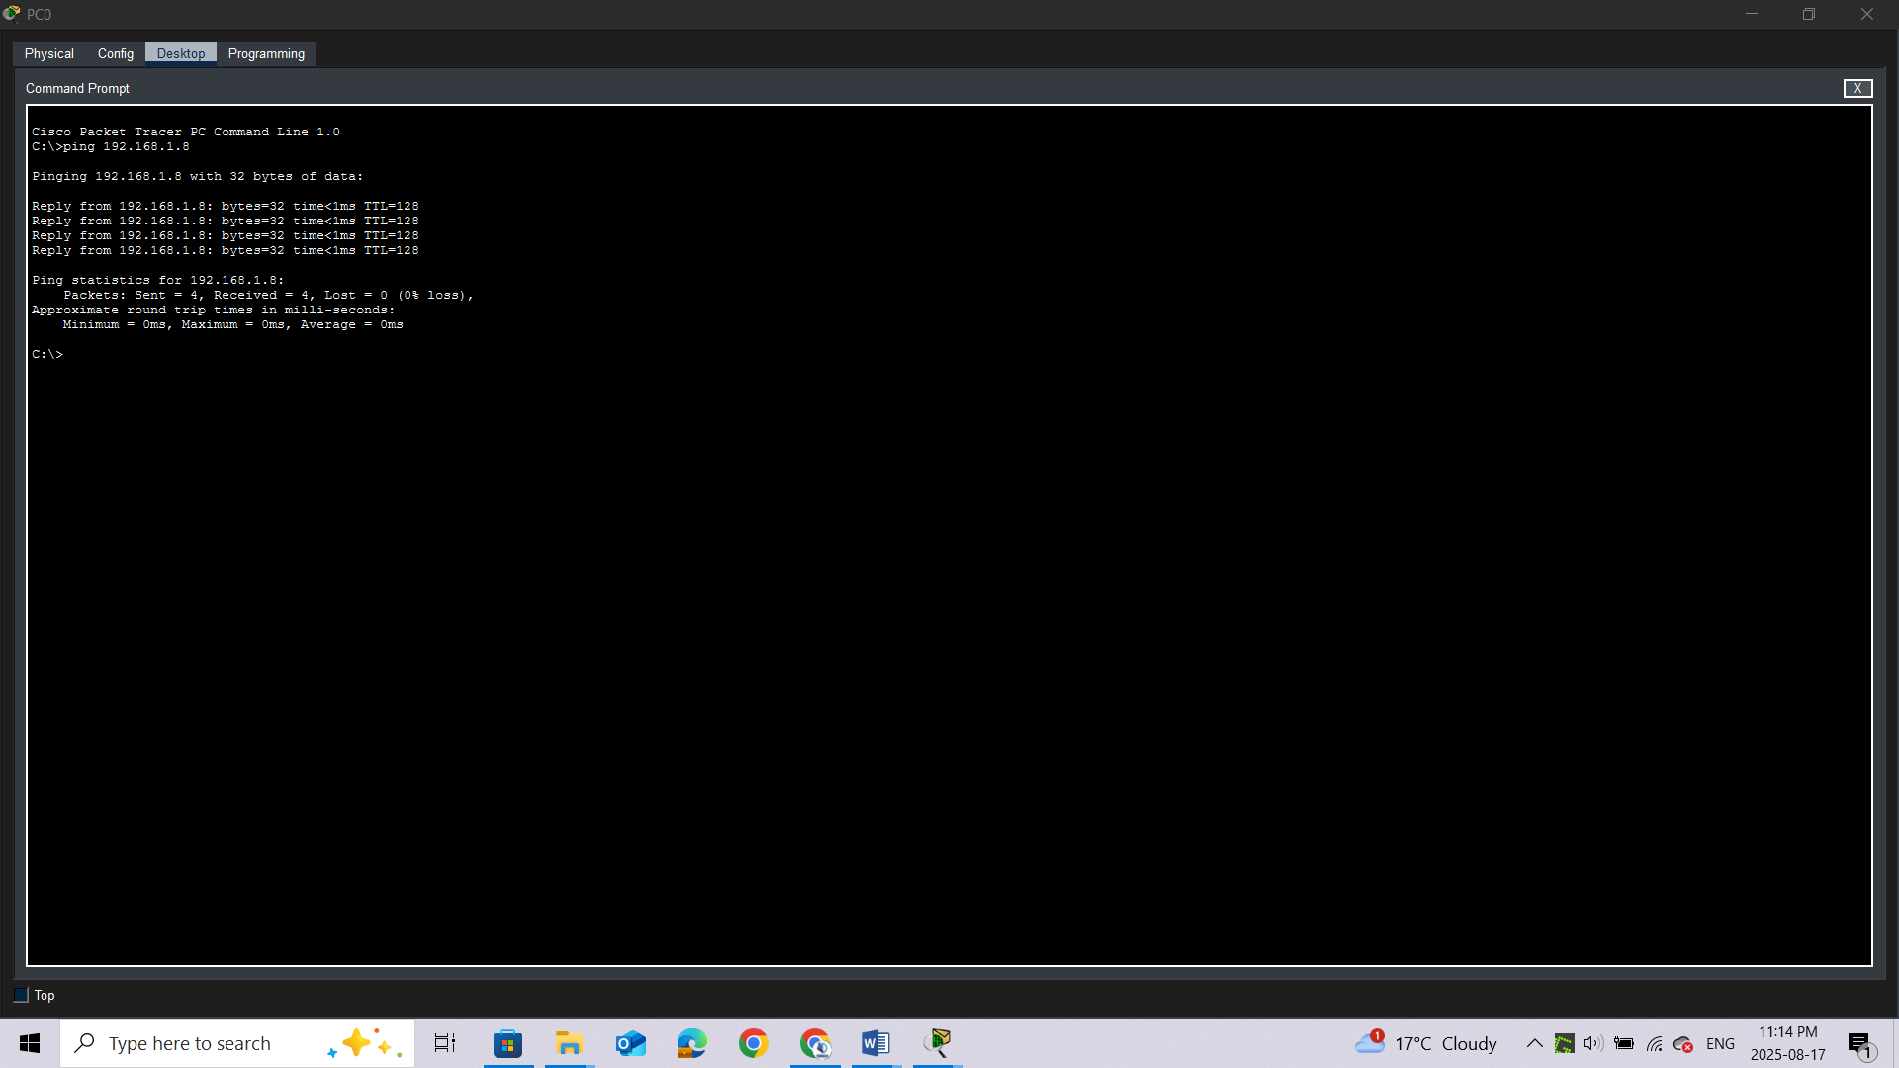

Unlike a LAN, a VLAN is a broadcast domain created by switches. Using Packet Tracer **Simulation** mode, ping the end devices within their own VLAN. Based on your observation, answer the questions in Step 2.

### Step 2: Generate and examine broadcast traffic in a VLAN implementation.

1. Switch to **Simulation** mode.

b.     Click **Edit Filters** in the Simulation Panel. Uncheck the **Show All/None** checkbox. Check the **ICMP** checkbox.

c.     Click the **Add Complex PDU** tool, this is the open envelope icon on the right toolbar.

d.     Float the mouse cursor over the topology and the pointer changes to an envelope with a plus (+) sign.

e.     Click **PC0** to serve as the source for this test message and the **Create Complex PDU**dialog window opens. Enter the following values:

o    Destination IP Address: 255.255.255.255 (broadcast address)

o    Sequence Number: 1

o    One Shot Time: 0

Within the PDU settings, the default for **Select Application:** is PING.

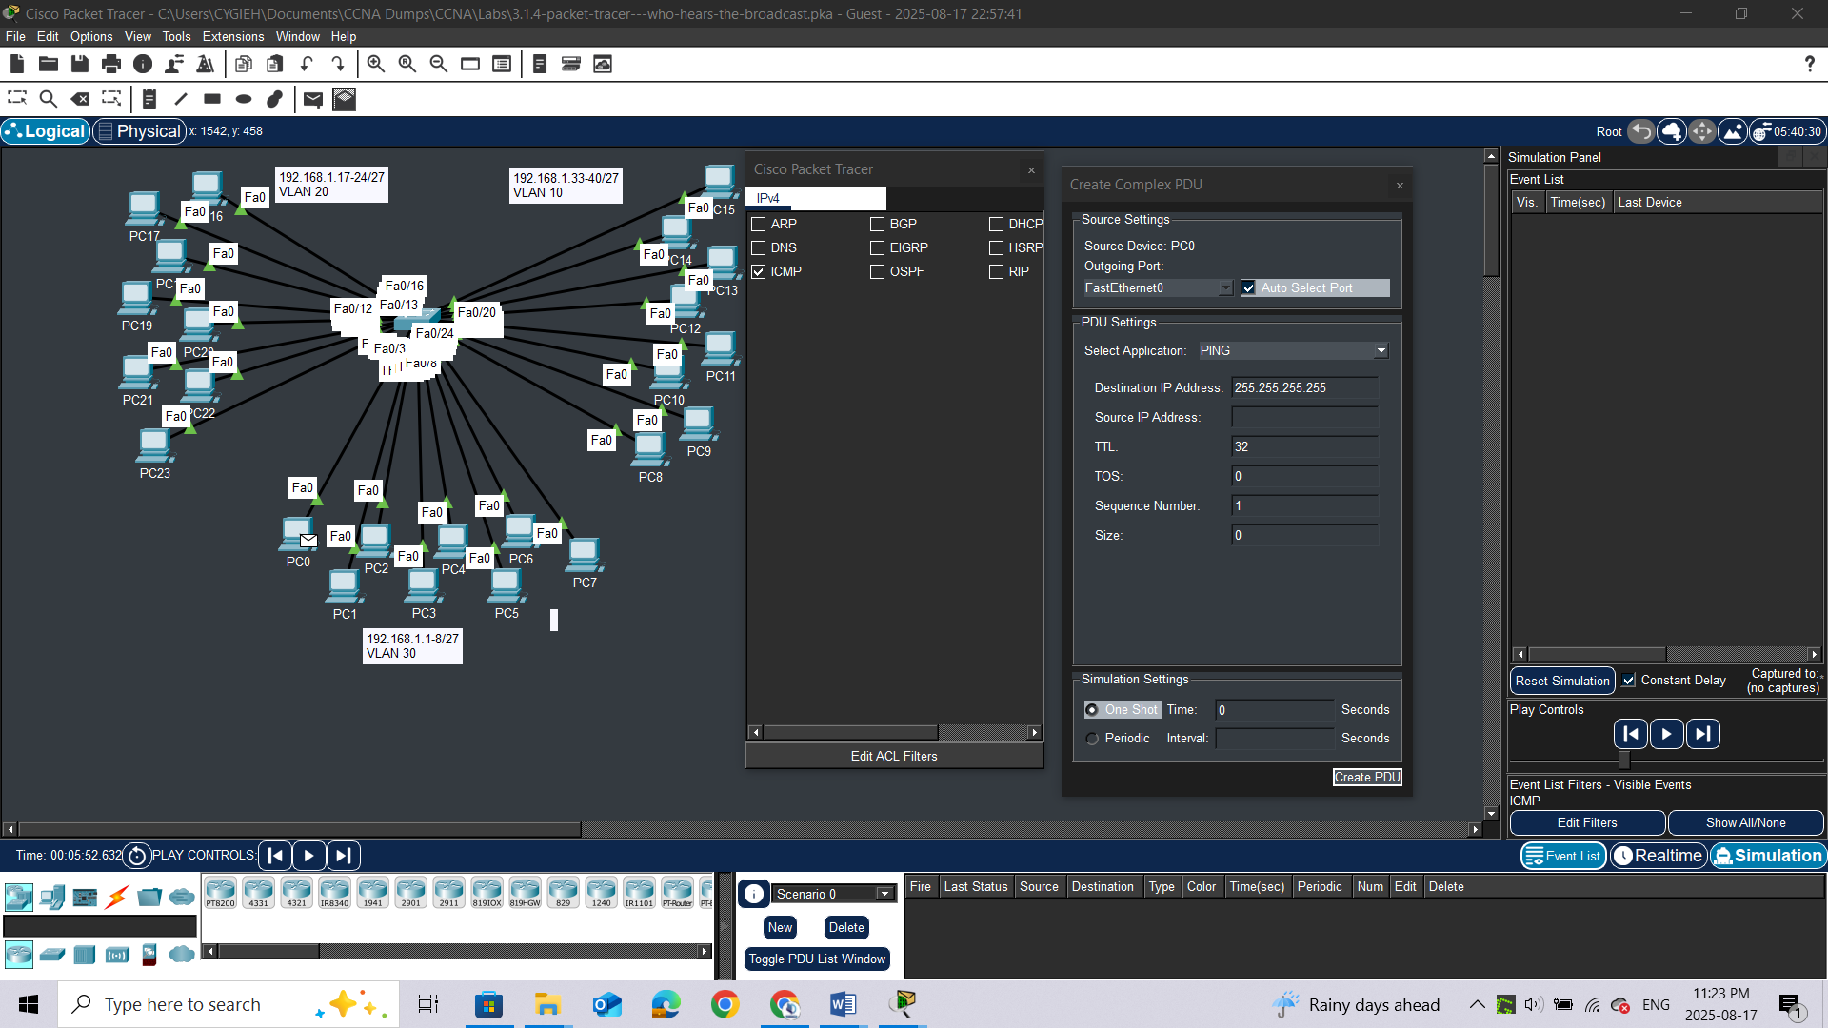**stion:**

What are at least 3 other applications available for use? ***DNS, FTP, HTTP, IMAP, NETBIOS, HTTPS***

f.      Click **Create PDU**. This test broadcast packet now appears in the **Simulation Panel Event List.**It also appears in the PDU List window. It is the first PDU for Scenario 0.

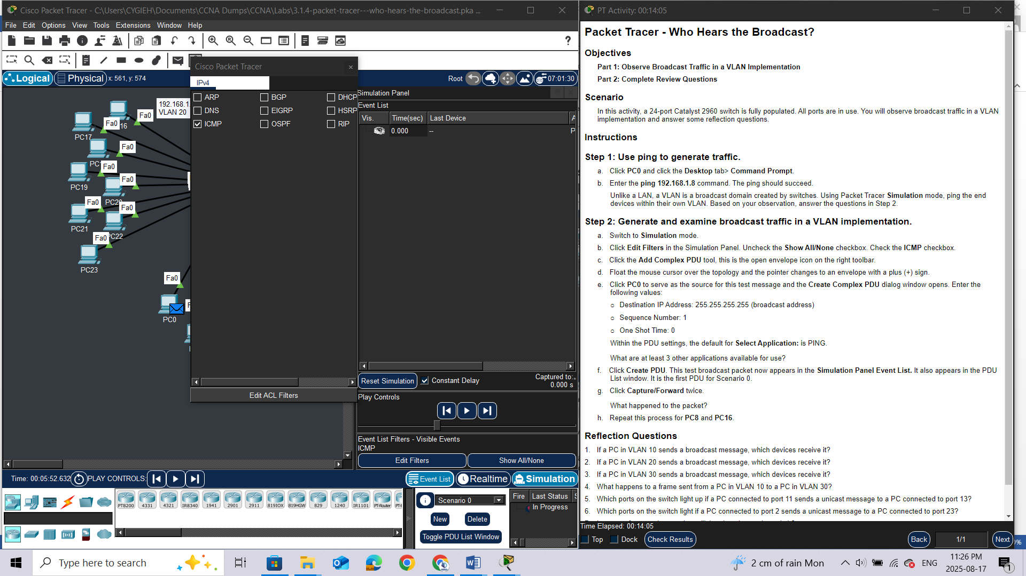

g.     Click**Capture/Forward** twice.**Question:**

What happened to the packet?

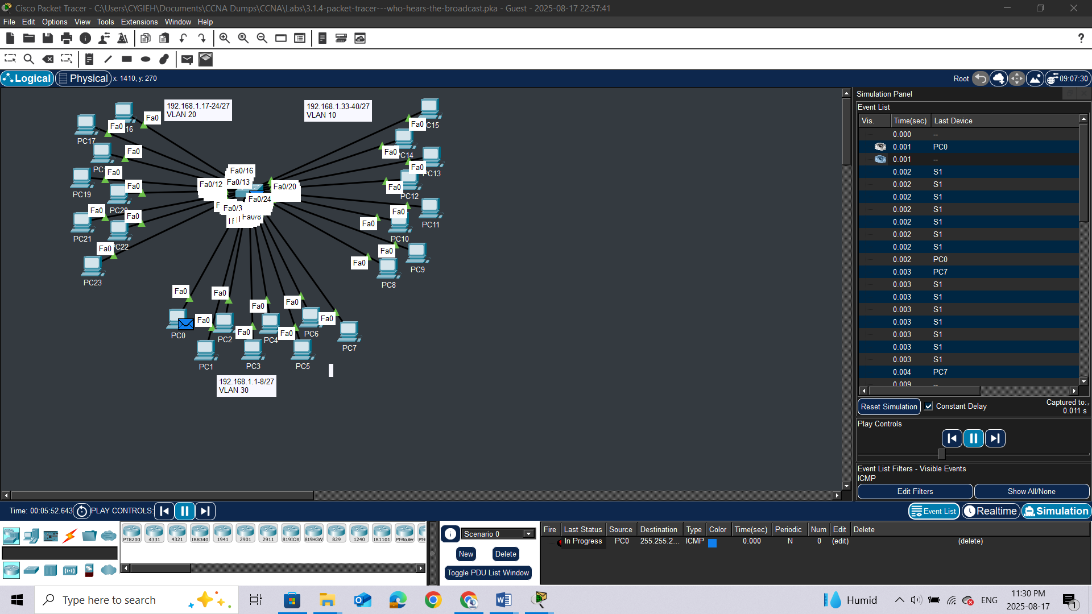

h.     Repeat this process for **PC8**and **PC16**.

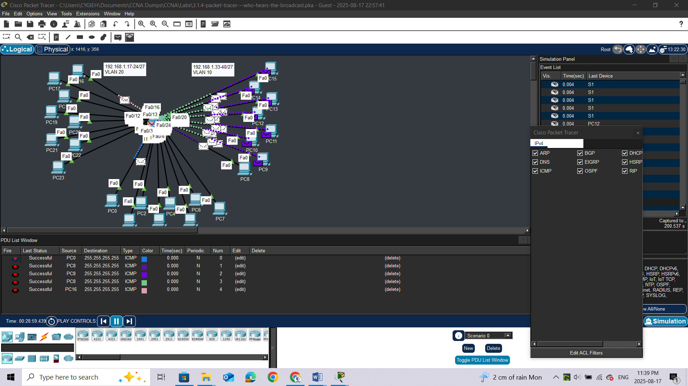

## Reflection Questions

1.     If a PC in VLAN 10 sends a broadcast message, which devices receive it?

2.     If a PC in VLAN 20 sends a broadcast message, which devices receive it?

3.     If a PC in VLAN 30 sends a broadcast message, which devices receive it?

4.     What happens to a frame sent from a PC in VLAN 10 to a PC in VLAN 30?

5.     Which ports on the switch light up if a PC connected to port 11 sends a unicast message to a PC connected to port 13?

6.     Which ports on the switch light if a PC connected to port 2 sends a unicast message to a PC connected to port 23?

7.     In terms of ports, what are the collision domains on the switch?

8.     In terms of ports, what are the broadcast domains on the switch?

# LAB 2: Packet Tracer - Investigate a VLAN Implementation

## Addressing Table

|  |  |  |  |  |
| --- | --- | --- | --- | --- |
| **Device** | **Interface** | **IP Address** | **Subnet Mask** | **Default Gateway** |
| S1 | VLAN 99 | 172.17.99.31 | 255.255.255.0 | N/A |
| S2 | VLAN 99 | 172.17.99.32 | 255.255.255.0 | N/A |
| S3 | VLAN 99 | 172.17.99.33 | 255.255.255.0 | N/A |
| PC1 | NIC | 172.17.10.21 | 255.255.255.0 | 172.17.10.1 |
| PC2 | NIC | 172.17.20.22 | 255.255.255.0 | 172.17.20.1 |
| PC3 | NIC | 172.17.30.23 | 255.255.255.0 | 172.17.30.1 |
| PC4 | NIC | 172.17.10.24 | 255.255.255.0 | 172.17.10.1 |
| PC5 | NIC | 172.17.20.25 | 255.255.255.0 | 172.17.20.1 |
| PC6 | NIC | 172.17.30.26 | 255.255.255.0 | 172.17.30.1 |
| PC7 | NIC | 172.17.10.27 | 255.255.255.0 | 172.17.10.1 |
| PC8 | NIC | 172.17.20.28 | 255.255.255.0 | 172.17.20.1 |
| PC9 | NIC | 172.17.30.29 | 255.255.255.0 | 172.17.30.1 |

## Objectives

**Part 1: Observe Broadcast Traffic in a VLAN Implementation**

**Part 2: Observe Broadcast Traffic without VLANs**

## Background

In this activity, you will observe how broadcast traffic is forwarded by the switches when VLANs are configured and when VLANs are not configured.

## Instructions

### Part 1: Observe Broadcast Traffic in a VLAN Implementation

#### Step 1: Ping from PC1 to PC6.

1. Wait for all the link lights to turn to green. To accelerate this process, click **Fast Forward Time** located in the bottom tool bar.

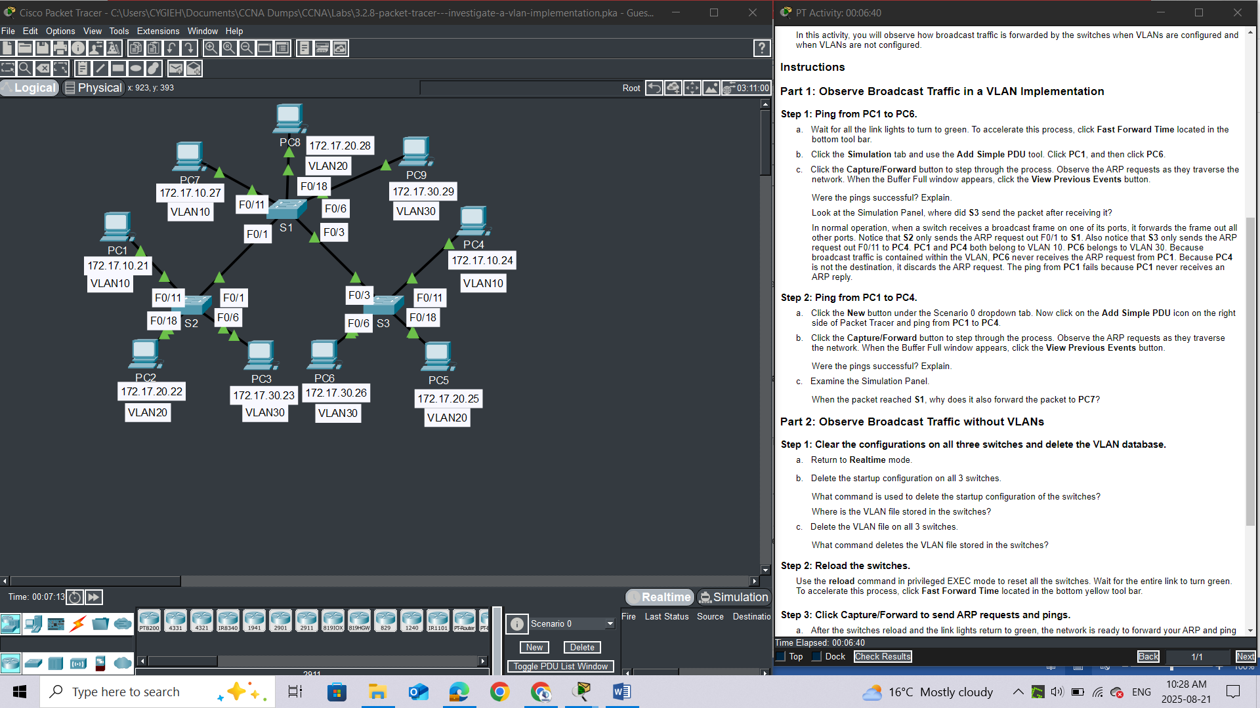

1. Click the **Simulation** tab and use the **Add Simple PDU** tool. Click **PC1**, and then click **PC6**.

c.     Click the **Capture/Forward** button to step through the process. Observe the ARP requests as they traverse the network. When the Buffer Full window appears, click the **View Previous Events** button.**Questions:**

Were the pings successful? Explain.

Look at the Simulation Panel, where did **S3** send the packet after receiving it?

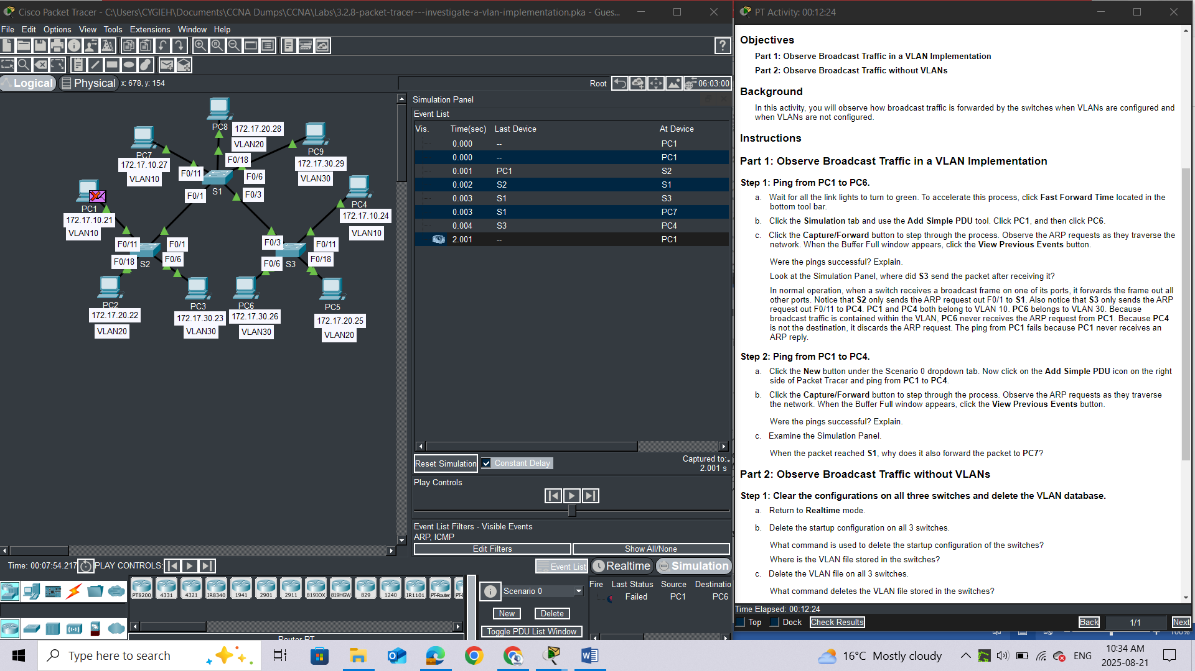

**ANSWER**

*In normal operation, when a switch receives a broadcast frame on one of its ports, it forwards the frame out all other ports. Notice that****S2****only sends the ARP request out F0/1 to****S1****. Also notice that****S3****only sends the ARP request out F0/11 to****PC4****.****PC1****and****PC4****both belong to VLAN 10.****PC6****belongs to VLAN 30. Because broadcast traffic is contained within the VLAN,****PC6****never receives the ARP request from****PC1****. Because****PC4****is not the destination, it discards the ARP request. The ping from****PC1****fails because****PC1****never receives an ARP reply.*

#### Step 2: Ping from PC1 to PC4.

a.     Click the **New** button under the Scenario 0 dropdown tab. Now click on the **Add Simple PDU** icon on the right side of Packet Tracer and ping from **PC1** to **PC4**.

b.     Click the **Capture/Forward** button to step through the process. Observe the ARP requests as they traverse the network. When the Buffer Full window appears, click the **View Previous Events** button.

Were the pings successful? Explain. ***Yes, The ping was successful because both PC1 and PC4 are in VLAN 10***

c.     Examine the Simulation Panel.

When the packet reached **S1**, why does it also forward the packet to **PC7**? ***Because PC7 is in VLAN10 too***

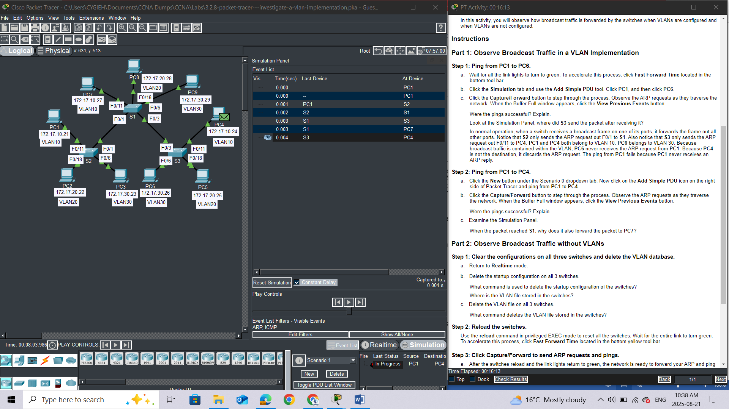

### Part 2: Observe Broadcast Traffic without VLANs

#### Step 1: Clear the configurations on all three switches and delete the VLAN database.

a.     Return to **Realtime** mode.

*Open configuration window*

1. Delete the startup configuration on all 3 switches.

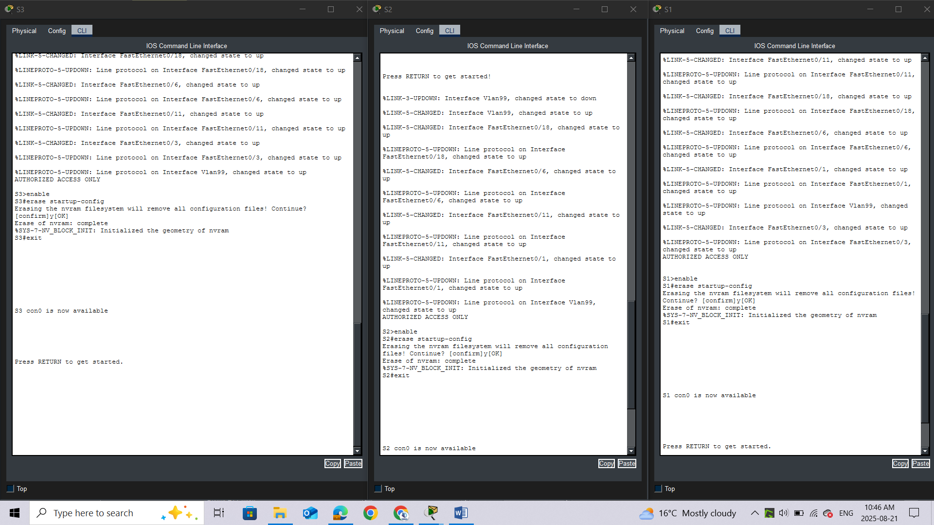

**Questions:**

What command is used to delete the startup configuration of the switches? ***erase startup-config***

Where is the VLAN file stored in the switches? in [***vlan.dat***](https://www.google.com/search?rlz=1C1GCCU_enKE1161KE1161&cs=0&sca_esv=53bbb5633a515c6e&sxsrf=AE3TifO-j36IiuBvvxYySCaPkFHj58T0Hg%3A1755762510195&q=vlan.dat&sa=X&ved=2ahUKEwi-0-mFtZuPAxWJUaQEHeuxPBEQxccNegQIAhAB&mstk=AUtExfAe7y97b5KaOVbpXiiFL67wpjZc_cQ5xF6gmRYfw2lTtSZBlZekWrzDWZ6B763gxWdR78JFJmYBwDPWxJR-sKcqz1LBofPEkkm9TP1OAYjpzX9nGlMgHth88RiW5Ken-wfbcobGXoOkF_tHE7cqhmz_Zi6VlDXn9aF8LBZd79zoBaNkdjVpxAiocPp-6BXXBVm4izsoFwqSua2S3QqMGx5LuXAKrvy8LIXwNnRDZ6fRgXr_aPhsmPstwAsW6t6Tv0vhO_dAhHo7gk485NMmj1KA&csui=3)***, which resides in the switch's***[***flash memory***](https://www.google.com/search?rlz=1C1GCCU_enKE1161KE1161&cs=0&sca_esv=53bbb5633a515c6e&sxsrf=AE3TifO-j36IiuBvvxYySCaPkFHj58T0Hg%3A1755762510195&q=flash+memory&sa=X&ved=2ahUKEwi-0-mFtZuPAxWJUaQEHeuxPBEQxccNegQIAhAC&mstk=AUtExfAe7y97b5KaOVbpXiiFL67wpjZc_cQ5xF6gmRYfw2lTtSZBlZekWrzDWZ6B763gxWdR78JFJmYBwDPWxJR-sKcqz1LBofPEkkm9TP1OAYjpzX9nGlMgHth88RiW5Ken-wfbcobGXoOkF_tHE7cqhmz_Zi6VlDXn9aF8LBZd79zoBaNkdjVpxAiocPp-6BXXBVm4izsoFwqSua2S3QqMGx5LuXAKrvy8LIXwNnRDZ6fRgXr_aPhsmPstwAsW6t6Tv0vhO_dAhHo7gk485NMmj1KA&csui=3)***.***

1. Delete the VLAN file on all 3 switches.

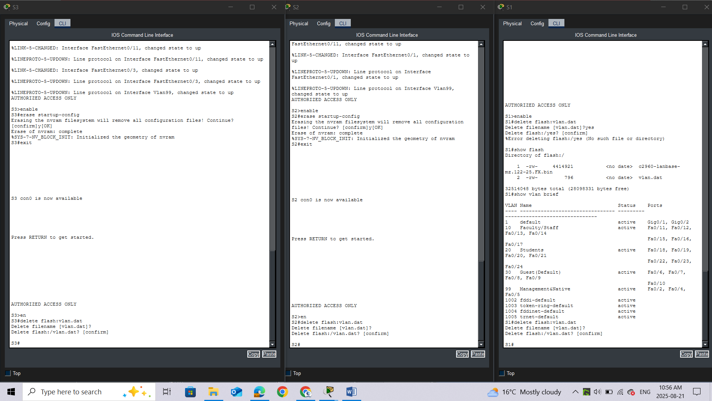What command deletes the VLAN file stored in the switches? ***delete flash:vlan.dat***

### Step 2: Reload the switches.

Use the **reload** command in privileged EXEC mode to reset all the switches.

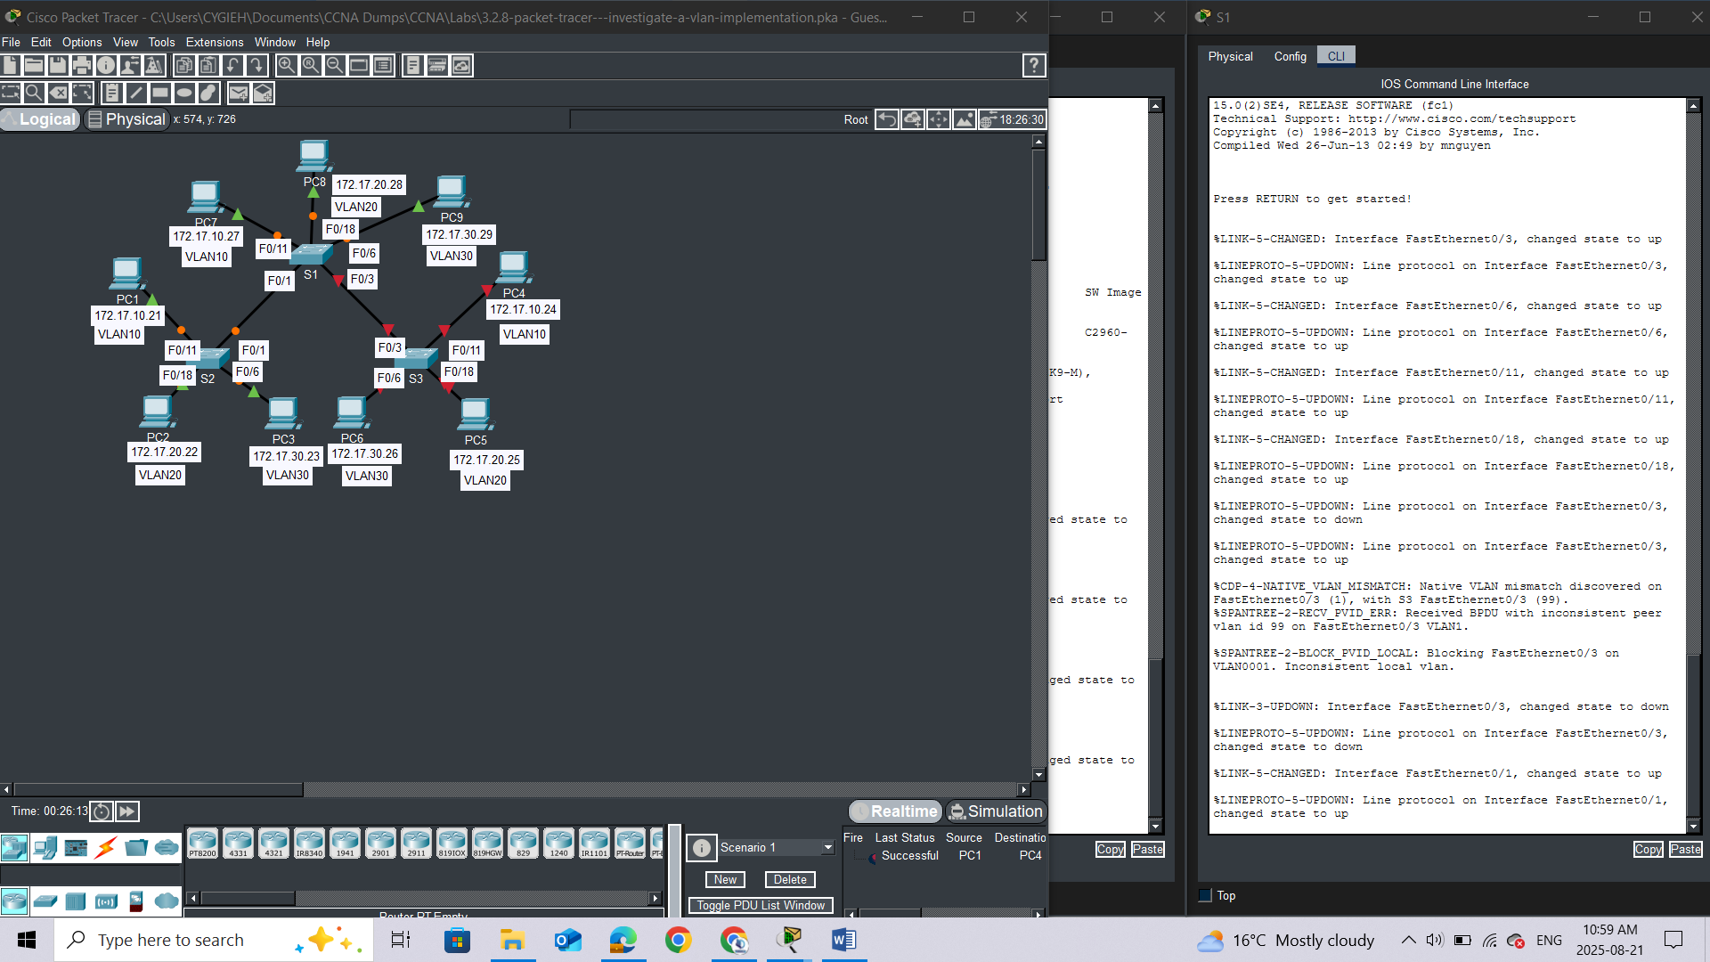

Wait for the entire link to turn green. To accelerate this process, click **Fast Forward Time** located in the bottom yellow tool bar.

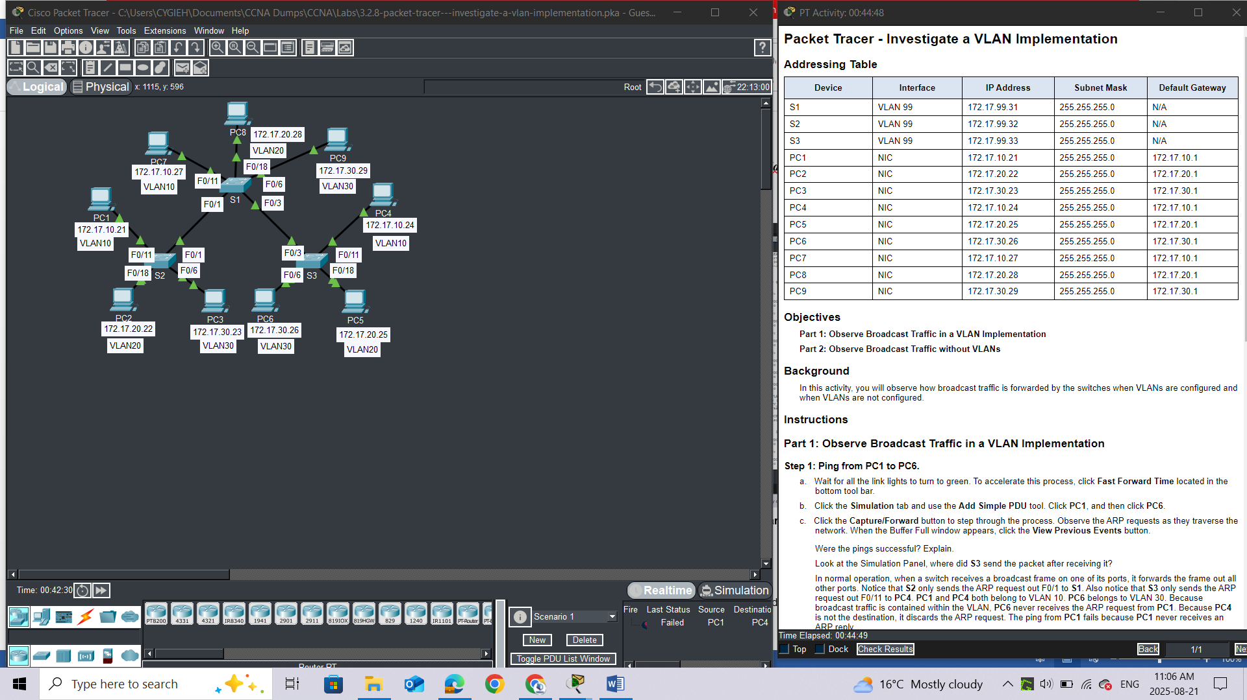

*Close configuration window*

### Step 3: Click Capture/Forward to send ARP requests and pings.

a.     After the switches reload and the link lights return to green, the network is ready to forward your ARP and ping traffic.

b.     Select **Scenario 0** from the drop-down tab to return to Scenario 0.

c.     From **Simulation**mode, click the **Capture/Forward** button to step through the process. Notice that the switches now forward the ARP requests out all ports, except the port on which the ARP request was received. This default action of switches is why VLANs can improve network performance. Broadcast traffic is contained within each VLAN. When the **Buffer Full** window appears, click the **View Previous Events** button.

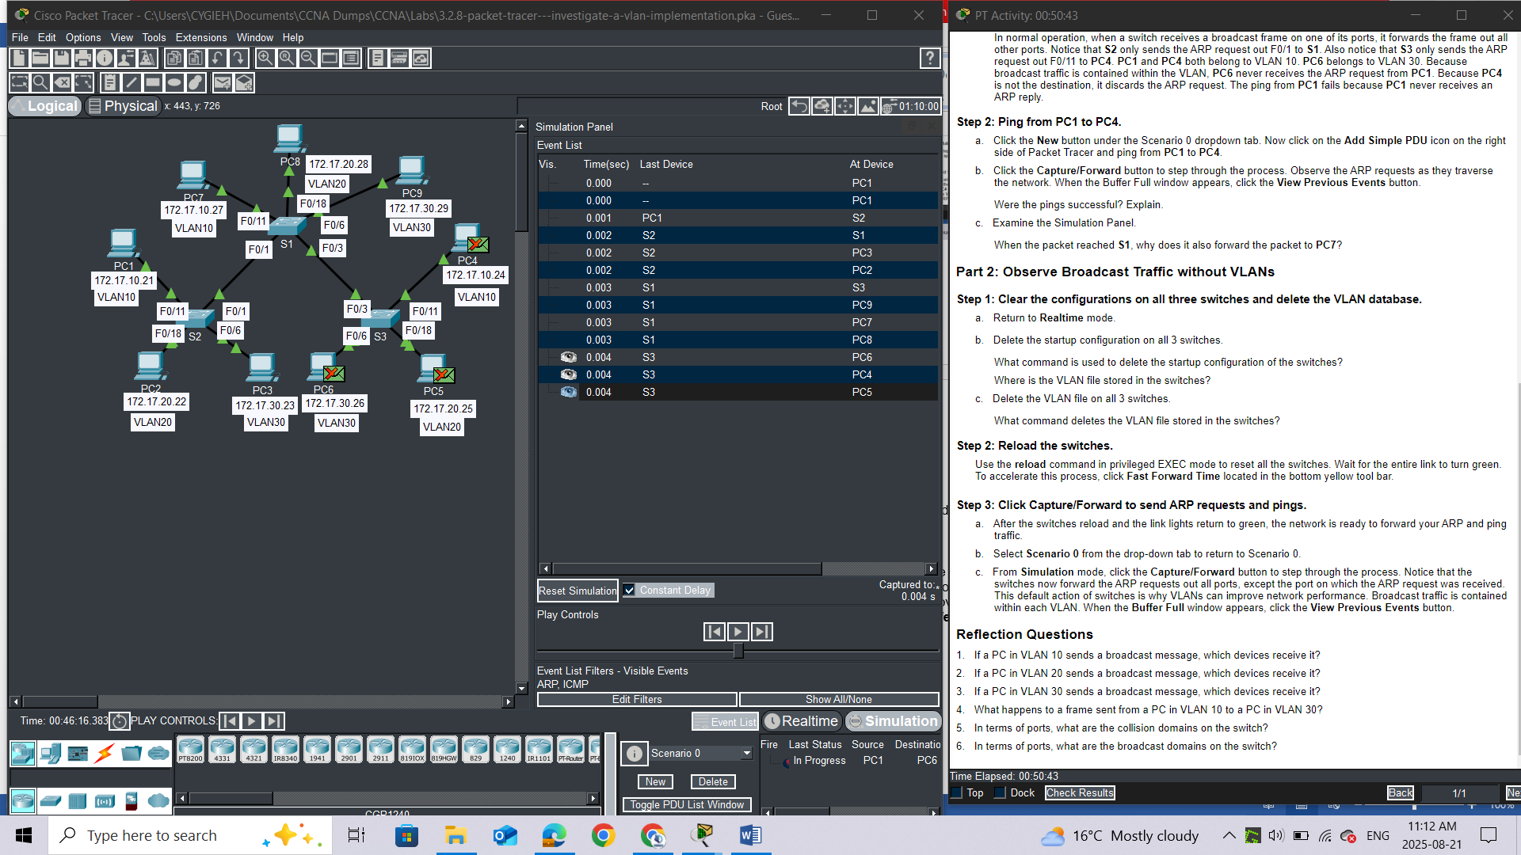

## Reflection Questions

1.     If a PC in VLAN 10 sends a broadcast message, which devices receive it? All devices

2.     If a PC in VLAN 20 sends a broadcast message, which devices receive it? All devices

3.     If a PC in VLAN 30 sends a broadcast message, which devices receive it? All devices

4.     What happens to a frame sent from a PC in VLAN 10 to a PC in VLAN 30?

5.     In terms of ports, what are the collision domains on the switch?

6.     In terms of ports, what are the broadcast domains on the switch?

# LAB 3: Packet Tracer - VLAN Configuration

## Addressing Table

|  |  |  |  |  |
| --- | --- | --- | --- | --- |
| **Device** | **Interface** | **IP Address** | **Subnet Mask** | **VLAN** |
| PC1 | NIC | 172.17.10.21 | 255.255.255.0 | 10 |
| PC2 | NIC | 172.17.20.22 | 255.255.255.0 | 20 |
| PC3 | NIC | 172.17.30.23 | 255.255.255.0 | 30 |
| PC4 | NIC | 172.17.10.24 | 255.255.255.0 | 10 |
| PC5 | NIC | 172.17.20.25 | 255.255.255.0 | 20 |
| PC6 | NIC | 172.17.30.26 | 255.255.255.0 | 30 |

## Objectives

**Part 1: Verify the Default VLAN Configuration**

**Part 2: Configure VLANs**

**Part 3: Assign VLANs to Ports**

## Background

VLANs are helpful in the administration of logical groups, allowing members of a group to be easily moved, changed, or added. This activity focuses on creating and naming VLANs, and assigning access ports to specific VLANs.

## Instructions

### Part 1: View the Default VLAN Configuration

#### Step 1: Display the current VLANs.

On S1, issue the command that displays all VLANs configured. By default, all interfaces are assigned to VLAN 1.

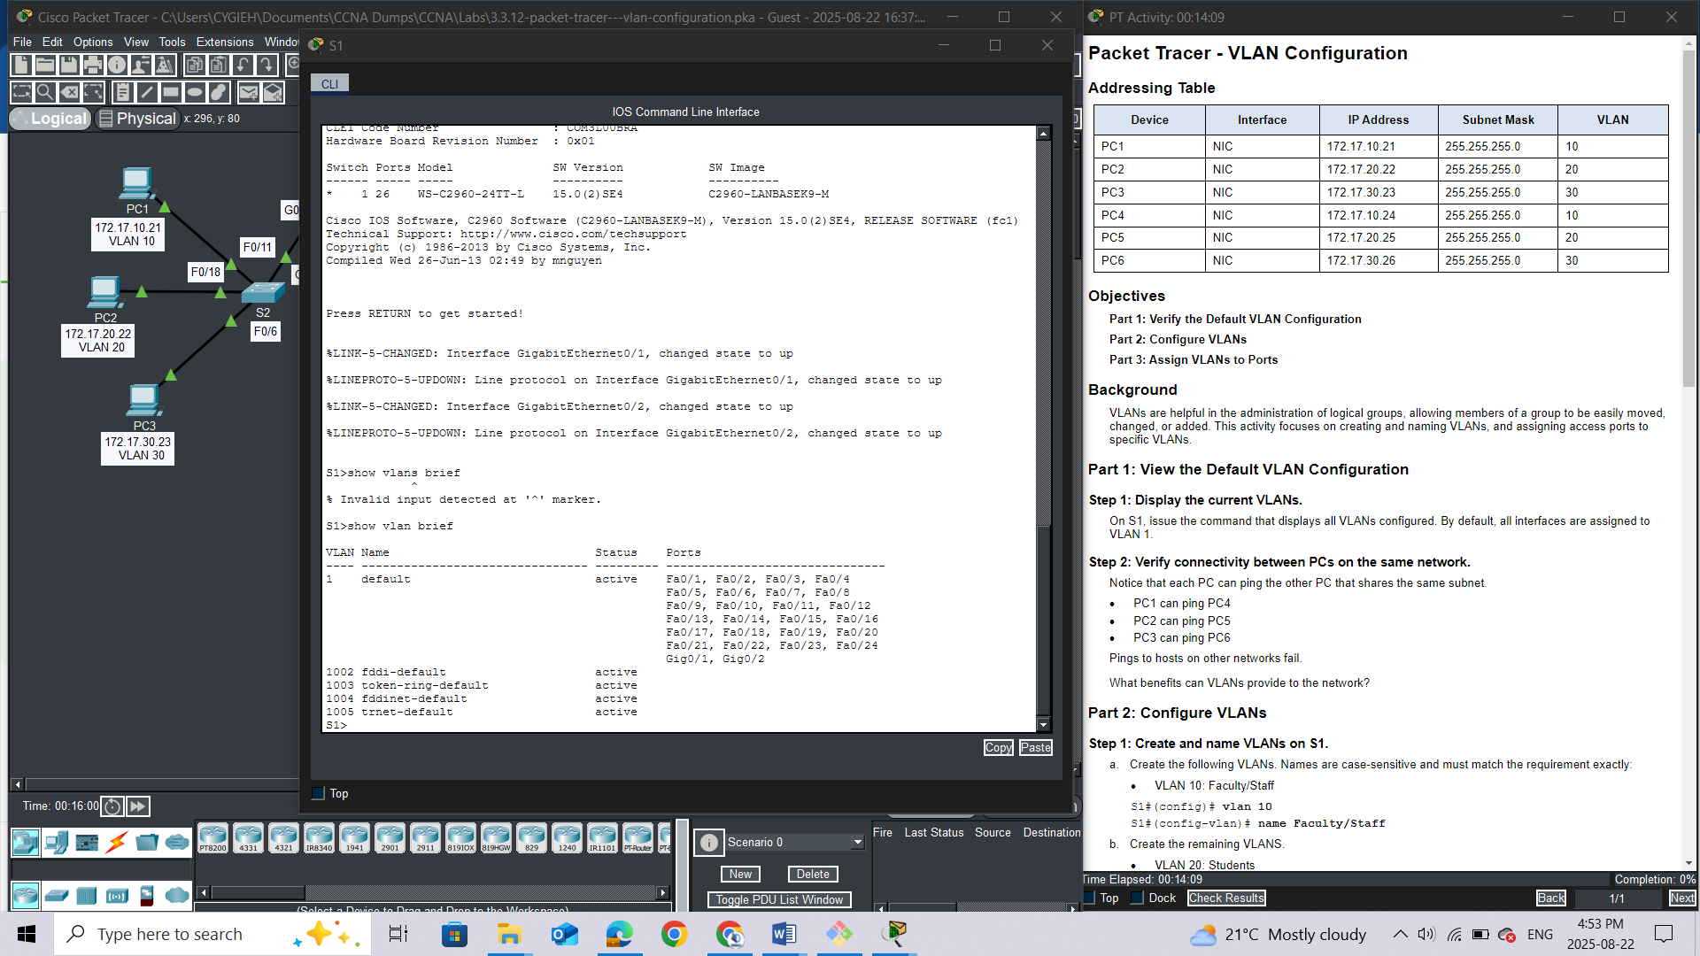

#### Step 2: Verify connectivity between PCs on the same network.

Notice that each PC can ping the other PC that shares the same subnet.

·         PC1 can ping PC4

·         PC2 can ping PC5

·         PC3 can ping PC6

Pings to hosts on other networks fail.

Question:

What benefits can VLANs provide to the network?

1. **Enhanced Security:**
   * **Segmentation:** VLANs divide a large network into smaller, isolated virtual networks, creating "virtual walls" that prevent unauthorized users and traffic from crossing into sensitive areas.
   * **Reduced Attack Surface:** By limiting the broadcast domain, VLANs decrease the chances of a successful data breach or an attack propagating throughout the entire network.
2. **Improved Network Performance:**
   * **Reduced Broadcast Traffic:** VLANs contain broadcasts within their respective segments, preventing excessive broadcast traffic from consuming network resources and causing congestion.
   * **Optimized Traffic Flow:** Each VLAN can be configured to handle only relevant traffic, allowing devices to process information more efficiently.
3. **Simplified Network Management:**
   * **Logical Grouping:** VLANs allow you to group devices logically by function, department, or application, rather than by their physical location.
   * **Ease of Administration:** This logical grouping simplifies network administration tasks, such as applying configurations, security policies, and updates to specific groups of users or devices.
4. **Flexibility and Scalability:**
   * **Adaptable to Changes:** When users or devices move to new physical locations but perform the same function, their VLAN membership can be changed without requiring physical reconfigurations.
   * **Easy Expansion:** VLANs provide a pathway for seamless network expansion, making it easier to add new users or services as the network grows.
5. **Cost-Effectiveness:**
   * **Hardware Optimization:** VLANs allow multiple logical networks to operate on a single physical network infrastructure, reducing the need for additional switches and hardware.
6. **Policy Enforcement:**
   * **Tailored Rules:** Administrators can define and enforce specific Quality of Service (QoS) rules, access control lists (ACLs), and other security policies for individual VLANs

### Part 2: Configure VLANs

#### Step 1: Create and name VLANs on S1.

a.     Create the following VLANs. Names are case-sensitive and must match the requirement exactly:

·         VLAN 10: Faculty/Staff

*Open configuration window*

S1#(config)# **vlan 10**

S1#(config-vlan)# **name Faculty/Staff**

b.     Create the remaining VLANS.

·         VLAN 20: Students

·         VLAN 30: Guest(Default)

·         VLAN 99: Management&Native

·         VLAN 150: VOICE

#### Step 2: Verify the VLAN configuration.

Question:

Which command will only display the VLAN name, status, and associated ports on a switch? **Show vlan brief**

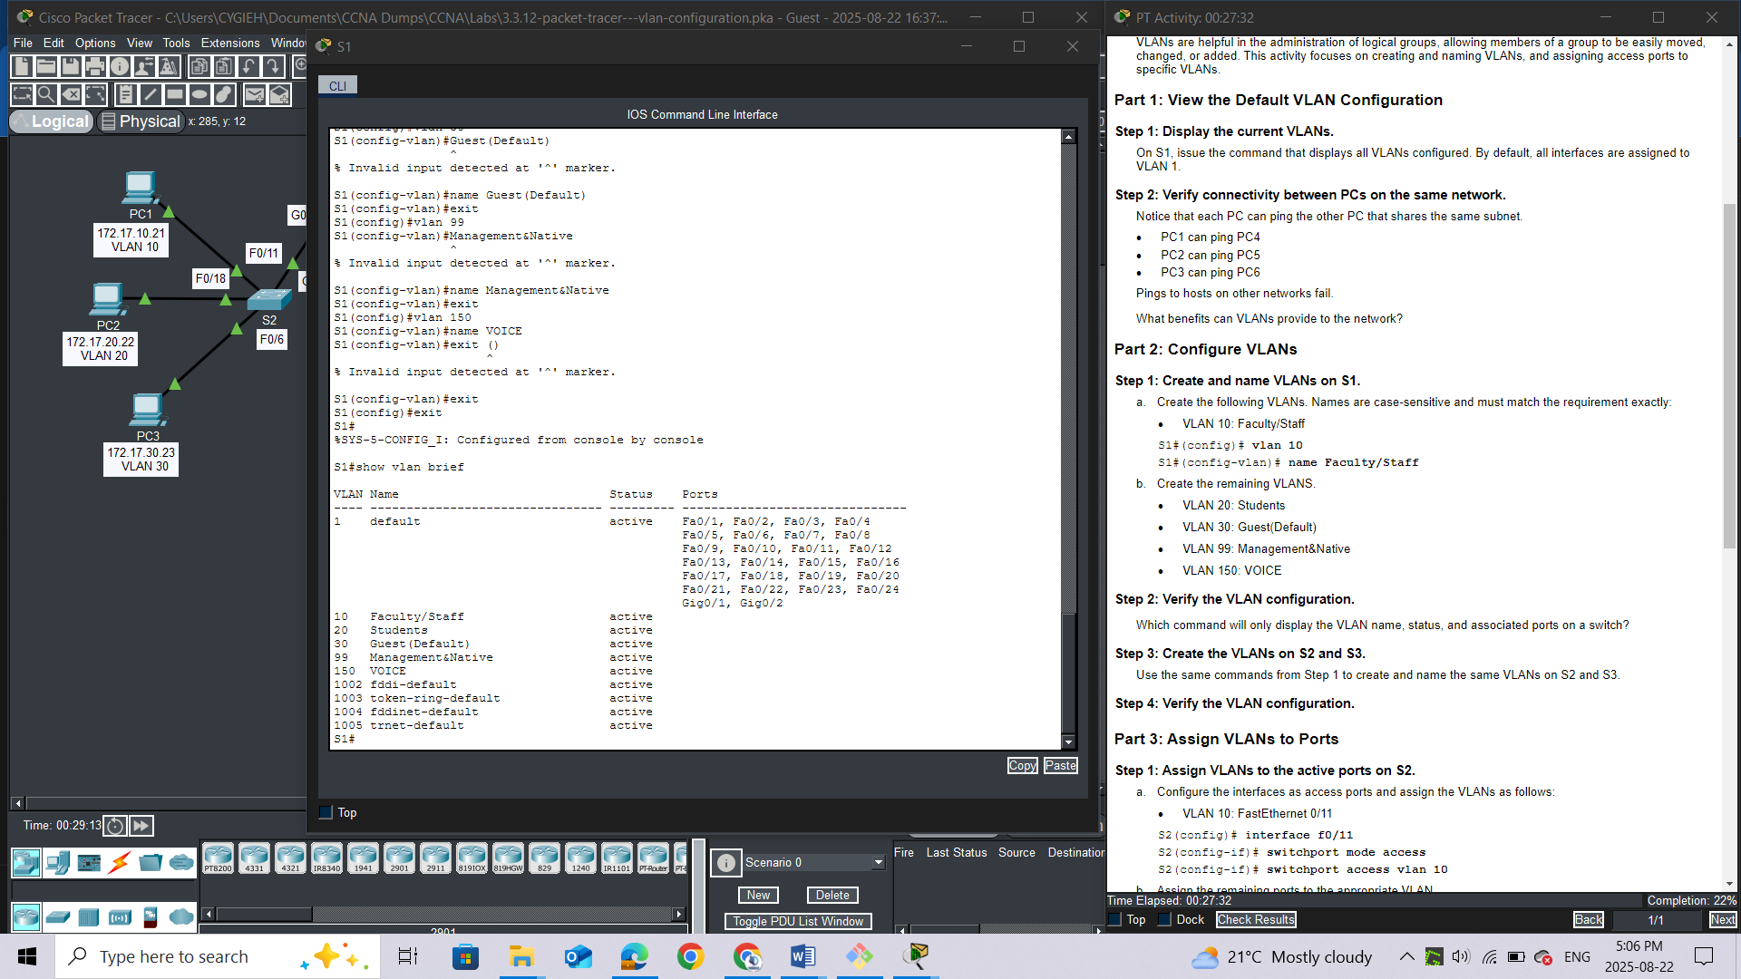

#### Step 3: Create the VLANs on S2 and S3.

Use the same commands from Step 1 to create and name the same VLANs on S2 and S3.

**S2**

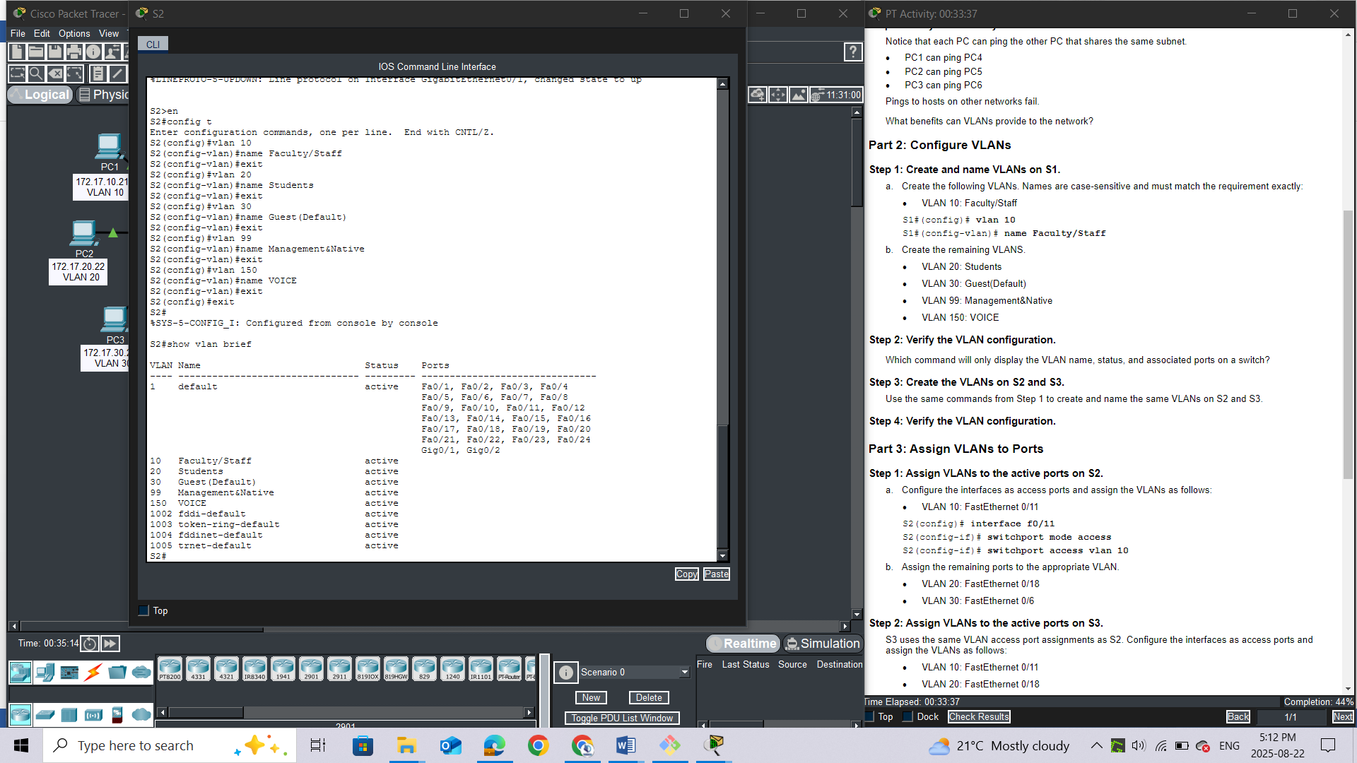

**S3**

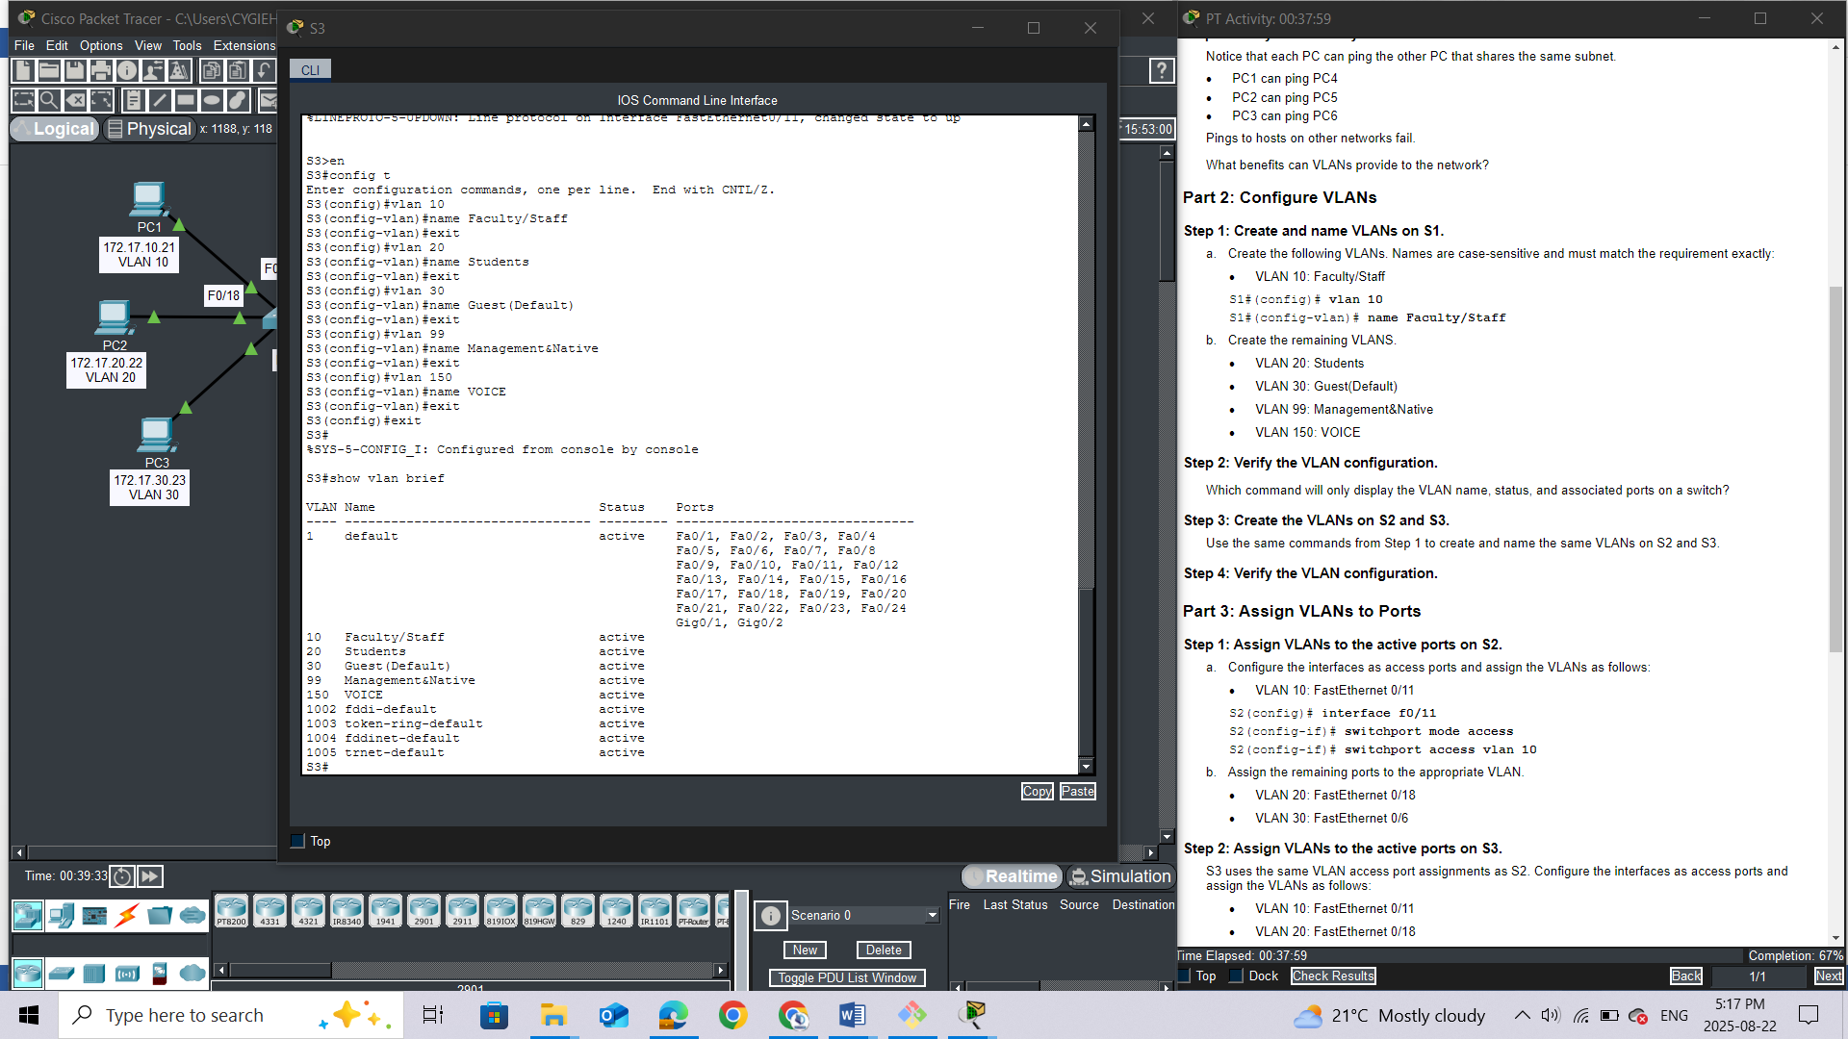

#### Step 4: Verify the VLAN configuration.

*Close configuration window*

### Part 3: Assign VLANs to Ports

#### Step 1: Assign VLANs to the active ports on S2.

a.     Configure the interfaces as access ports and assign the VLANs as follows:

·         VLAN 10: FastEthernet 0/11

*Open configuration window*

S2(config)# **interface f0/11**

S2(config-if)# **switchport mode access**

S2(config-if)# **switchport access vlan 10**

b.     Assign the remaining ports to the appropriate VLAN.

·         VLAN 20: FastEthernet 0/18

·         VLAN 30: FastEthernet 0/6

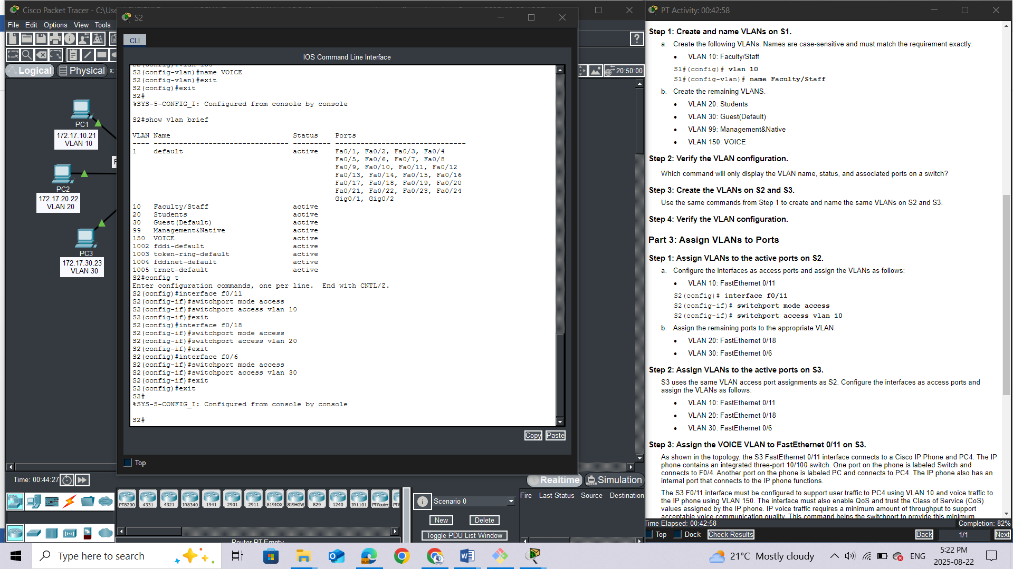

#### Step 2: Assign VLANs to the active ports on S3.

S3 uses the same VLAN access port assignments as S2. Configure the interfaces as access ports and assign the VLANs as follows:

·         VLAN 10: FastEthernet 0/11

·         VLAN 20: FastEthernet 0/18

·         VLAN 30: FastEthernet 0/6

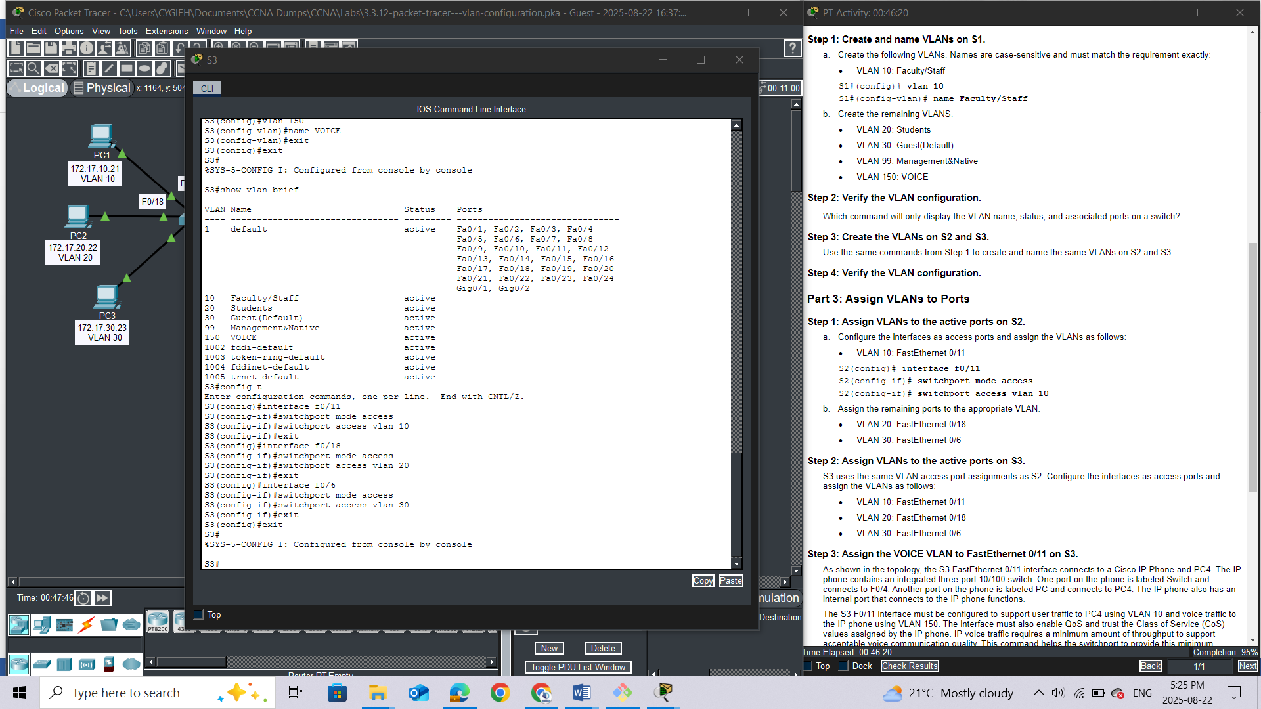

#### Step 3: Assign the VOICE VLAN to FastEthernet 0/11 on S3.

As shown in the topology, the S3 FastEthernet 0/11 interface connects to a Cisco IP Phone and PC4. The IP phone contains an integrated three-port 10/100 switch. One port on the phone is labeled Switch and connects to F0/4. Another port on the phone is labeled PC and connects to PC4. The IP phone also has an internal port that connects to the IP phone functions.

The S3 F0/11 interface must be configured to support user traffic to PC4 using VLAN 10 and voice traffic to the IP phone using VLAN 150. The interface must also enable QoS and trust the Class of Service (CoS) values assigned by the IP phone. IP voice traffic requires a minimum amount of throughput to support acceptable voice communication quality. This command helps the switchport to provide this minimum amount of throughput.

S3(config)# **interface f0/11**

S3(config-if)# **mls qos trust cos**

S3(config-if)# **switchport voice vlan 150**

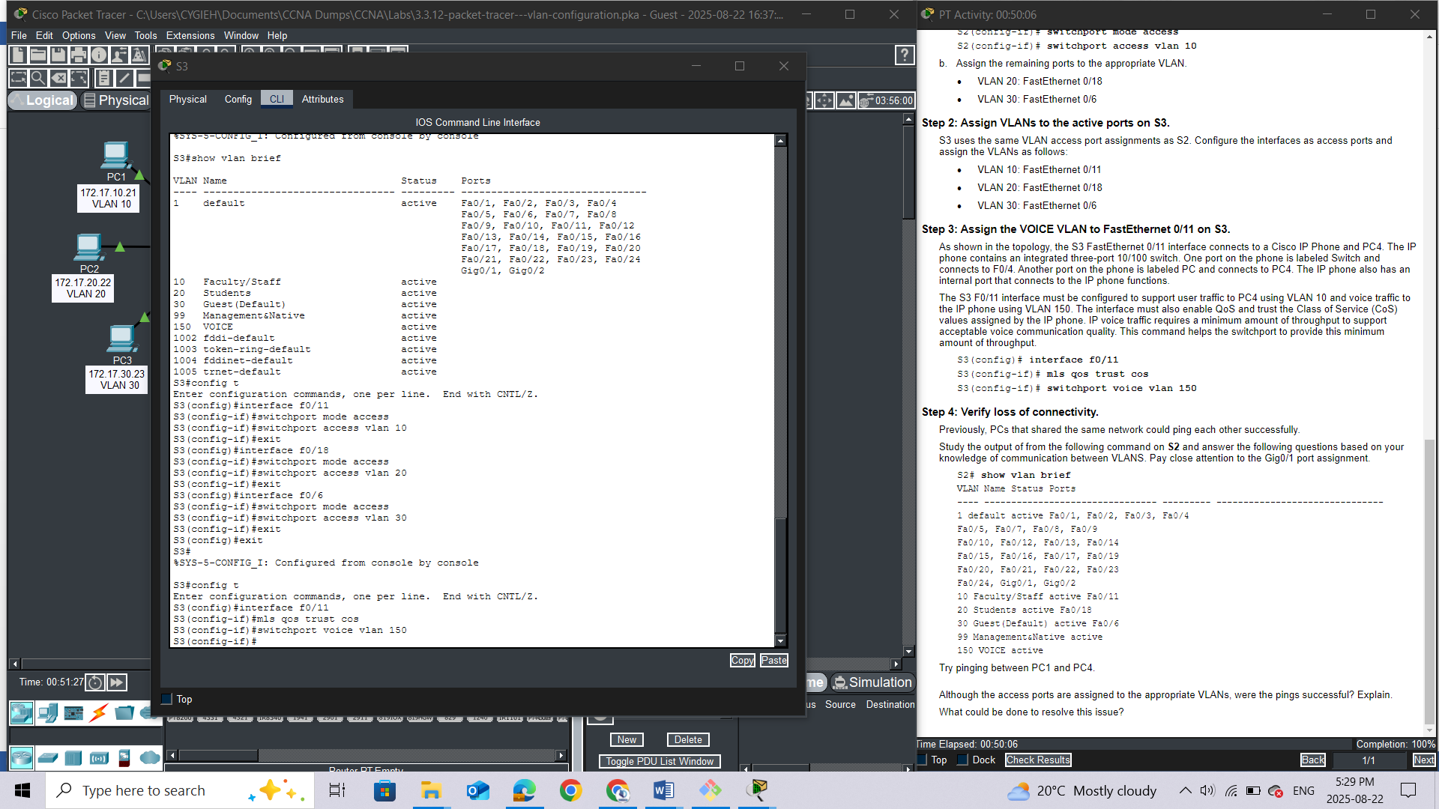

#### Step 4: Verify loss of connectivity.

Previously, PCs that shared the same network could ping each other successfully.

Study the output of from the following command on **S2** and answer the following questions based on your knowledge of communication between VLANS. Pay close attention to the Gig0/1 port assignment.

S2# **show vlan brief**

VLAN Name Status Ports

---- -------------------------------- --------- -------------------------------

1 default active Fa0/1, Fa0/2, Fa0/3, Fa0/4

Fa0/5, Fa0/7, Fa0/8, Fa0/9

Fa0/10, Fa0/12, Fa0/13, Fa0/14

Fa0/15, Fa0/16, Fa0/17, Fa0/19

Fa0/20, Fa0/21, Fa0/22, Fa0/23

Fa0/24, Gig0/1, Gig0/2

10 Faculty/Staff active Fa0/11

20 Students active Fa0/18

30 Guest(Default) active Fa0/6

99 Management&Native active

150 VOICE active

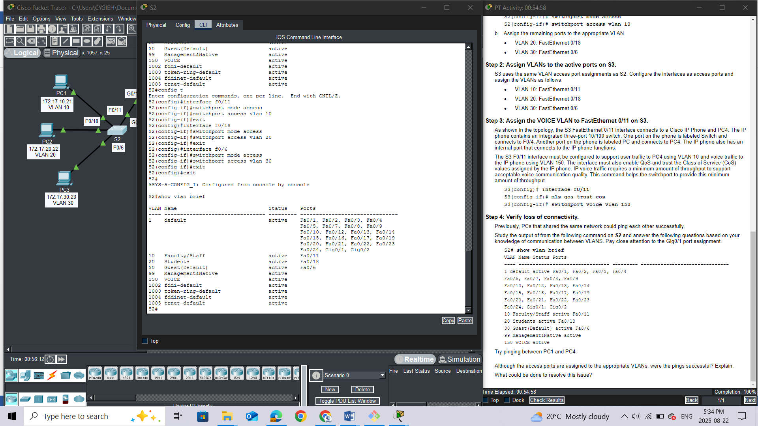

Try pinging between PC1 and PC4.

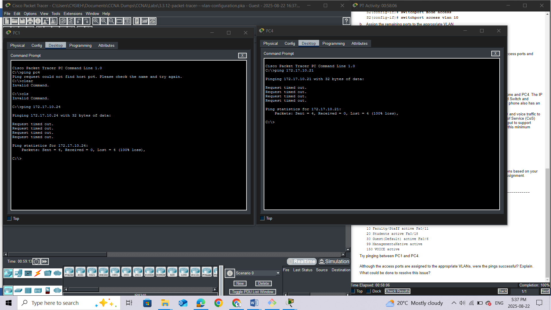

## Questions:

Although the access ports are assigned to the appropriate VLANs, were the pings successful? Explain.

***No, the ports connecting the switches are assigned to VLAN 1 by default.***

What could be done to resolve this issue? ***In order to provide connectivity between the PCs on the same network and VLAN, trunks must be configured.***

# Lab 4:Packet Tracer - Configure Trunks

## Addressing Table

|  |  |  |  |  |  |
| --- | --- | --- | --- | --- | --- |
| **Device** | **Interface** | **IP Address** | **Subnet Mask** | **Switch Port** | **VLAN** |
| PC1 | NIC | 172.17.10.21 | 255.255.255.0 | S2 F0/11 | 10 |
| PC2 | NIC | 172.17.20.22 | 255.255.255.0 | S2 F0/18 | 20 |
| PC3 | NIC | 172.17.30.23 | 255.255.255.0 | S2 F0/6 | 30 |
| PC4 | NIC | 172.17.10.24 | 255.255.255.0 | S3 F0/11 | 10 |
| PC5 | NIC | 172.17.20.25 | 255.255.255.0 | S3 F0/18 | 20 |
| PC6 | NIC | 172.17.30.26 | 255.255.255.0 | S3 F0/6 | 30 |

## Objectives

**Part 1: Verify VLANs**

**Part 2: Configure Trunks**

## Background

Trunks are required to pass VLAN information between switches. A port on a switch is either an access port or a trunk port. Access ports carry traffic from a specific VLAN assigned to the port. A trunk port by default is a member of all VLANs. Therefore, it carries traffic for all VLANs. This activity focuses on creating trunk ports and assigning them to a native VLAN other than the default.

## Instructions

### Part 1: Verify VLANs

#### Step 1: Display the current VLANs.

*Open configuration window*

1. On **S1**, issue the command that will display all VLANs configured. There should be ten VLANs in total. Notice that all 26 access ports on the switch are assigned to VLAN 1.

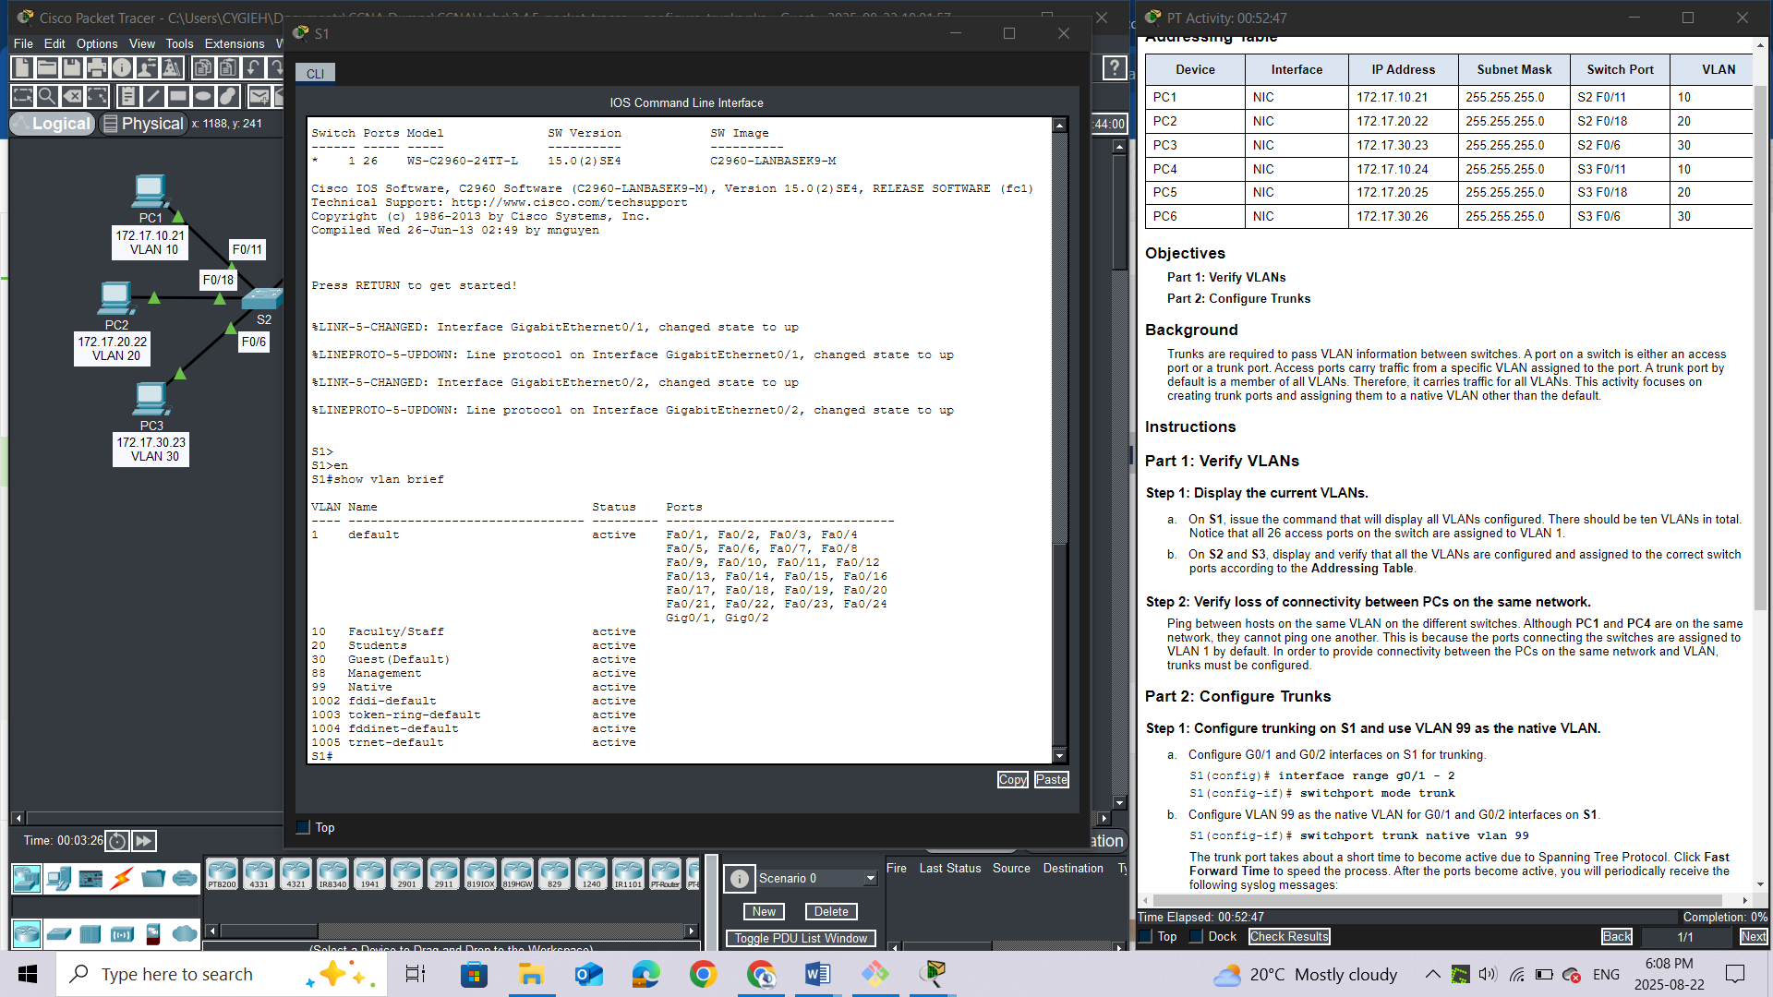

1. On **S2** and **S3**, display and verify that all the VLANs are configured and assigned to the correct switch ports according to the **Addressing Table**.

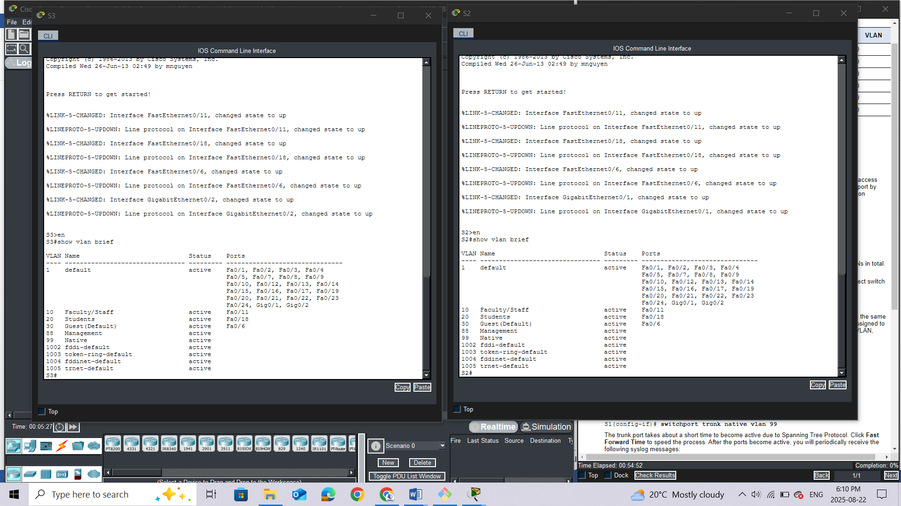

*Close configuration window*

#### Step 2: Verify loss of connectivity between PCs on the same network.

Ping between hosts on the same VLAN on the different switches. Although **PC1** and **PC4** are on the same network, they cannot ping one another. This is because the ports connecting the switches are assigned to VLAN 1 by default. In order to provide connectivity between the PCs on the same network and VLAN, trunks must be configured.

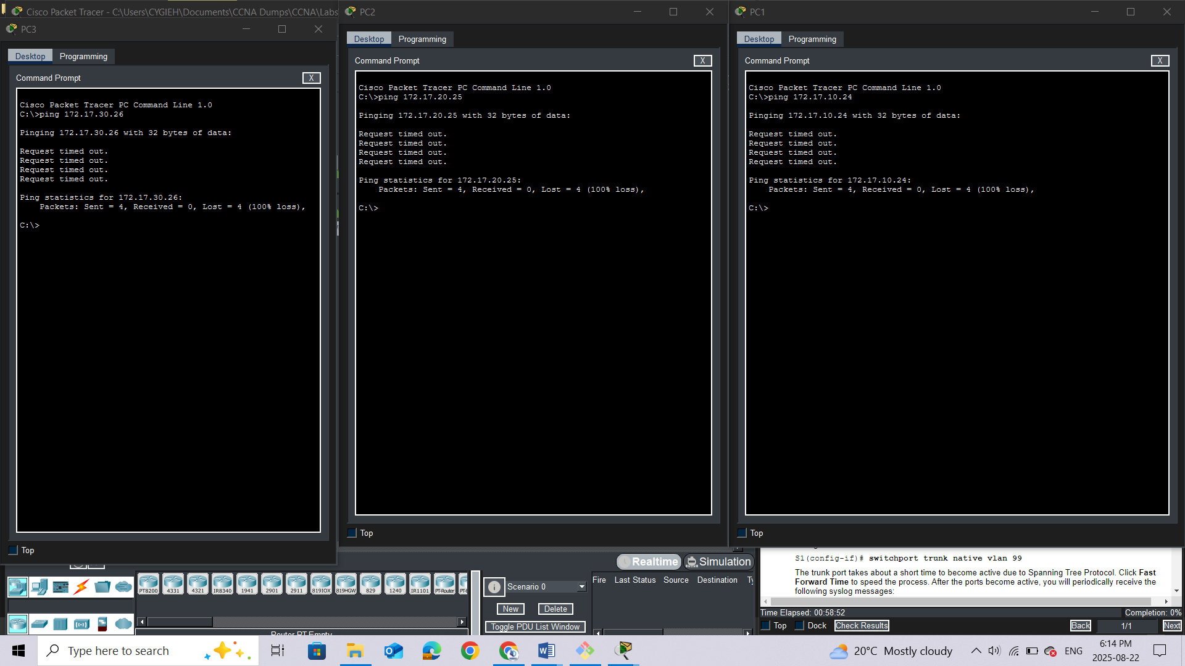

### Part 2: Configure Trunks

#### Step 1: Configure trunking on S1 and use VLAN 99 as the native VLAN.

*Open configuration window*

a.     Configure G0/1 and G0/2 interfaces on S1 for trunking.

S1(config)# **interface range g0/1 - 2**

S1(config-if)# **switchport mode trunk**

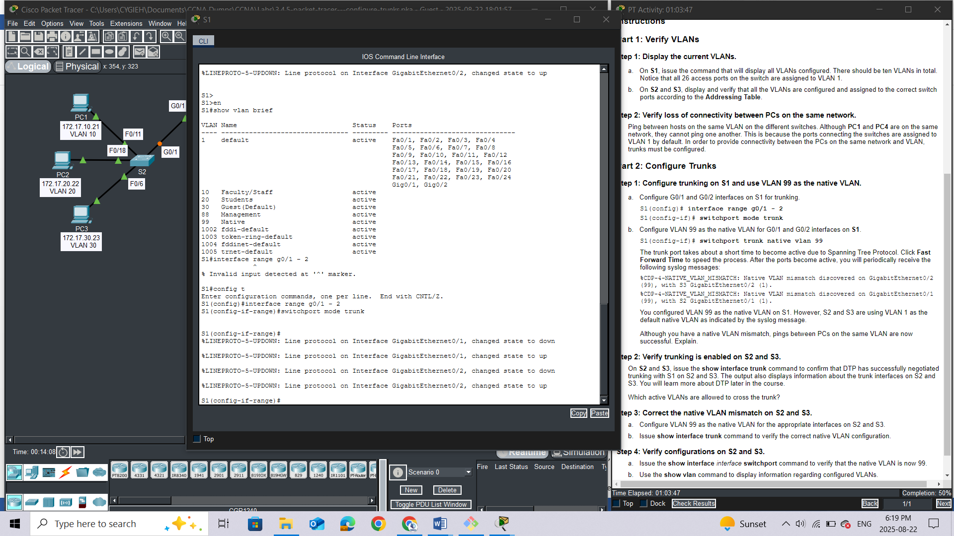

b.     Configure VLAN 99 as the native VLAN for G0/1 and G0/2 interfaces on **S1**.

S1(config-if)# **switchport trunk native vlan 99**

The trunk port takes about a short time to become active due to Spanning Tree Protocol. Click **Fast Forward Time** to speed the process. After the ports become active, you will periodically receive the following syslog messages:

%CDP-4-NATIVE_VLAN_MISMATCH: Native VLAN mismatch discovered on GigabitEthernet0/2 (99), with S3 GigabitEthernet0/2 (1).

%CDP-4-NATIVE_VLAN_MISMATCH: Native VLAN mismatch discovered on GigabitEthernet0/1 (99), with S2 GigabitEthernet0/1 (1).

You configured VLAN 99 as the native VLAN on S1. However, S2 and S3 are using VLAN 1 as the default native VLAN as indicated by the syslog message.

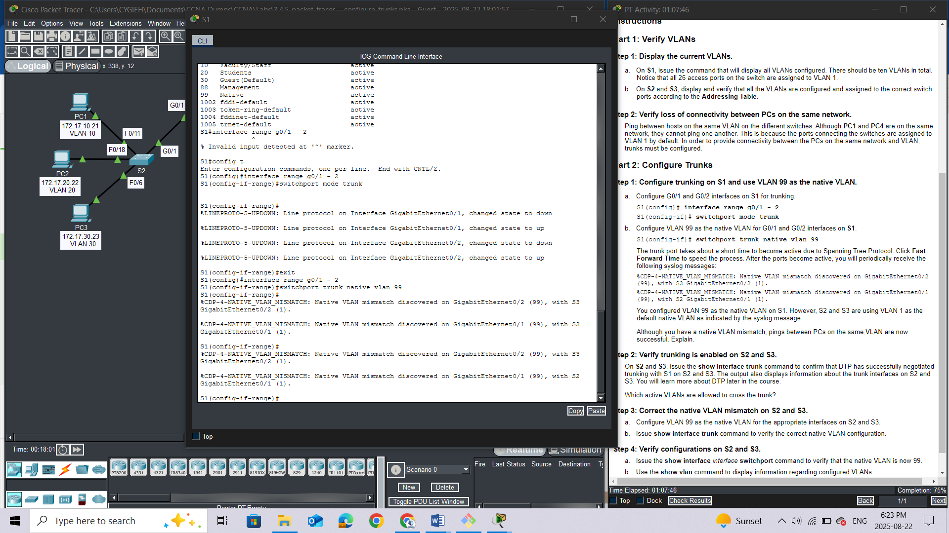

Question:

Although you have a native VLAN mismatch, pings between PCs on the same VLAN are now successful. Explain. ***This is because trunking has been configured***

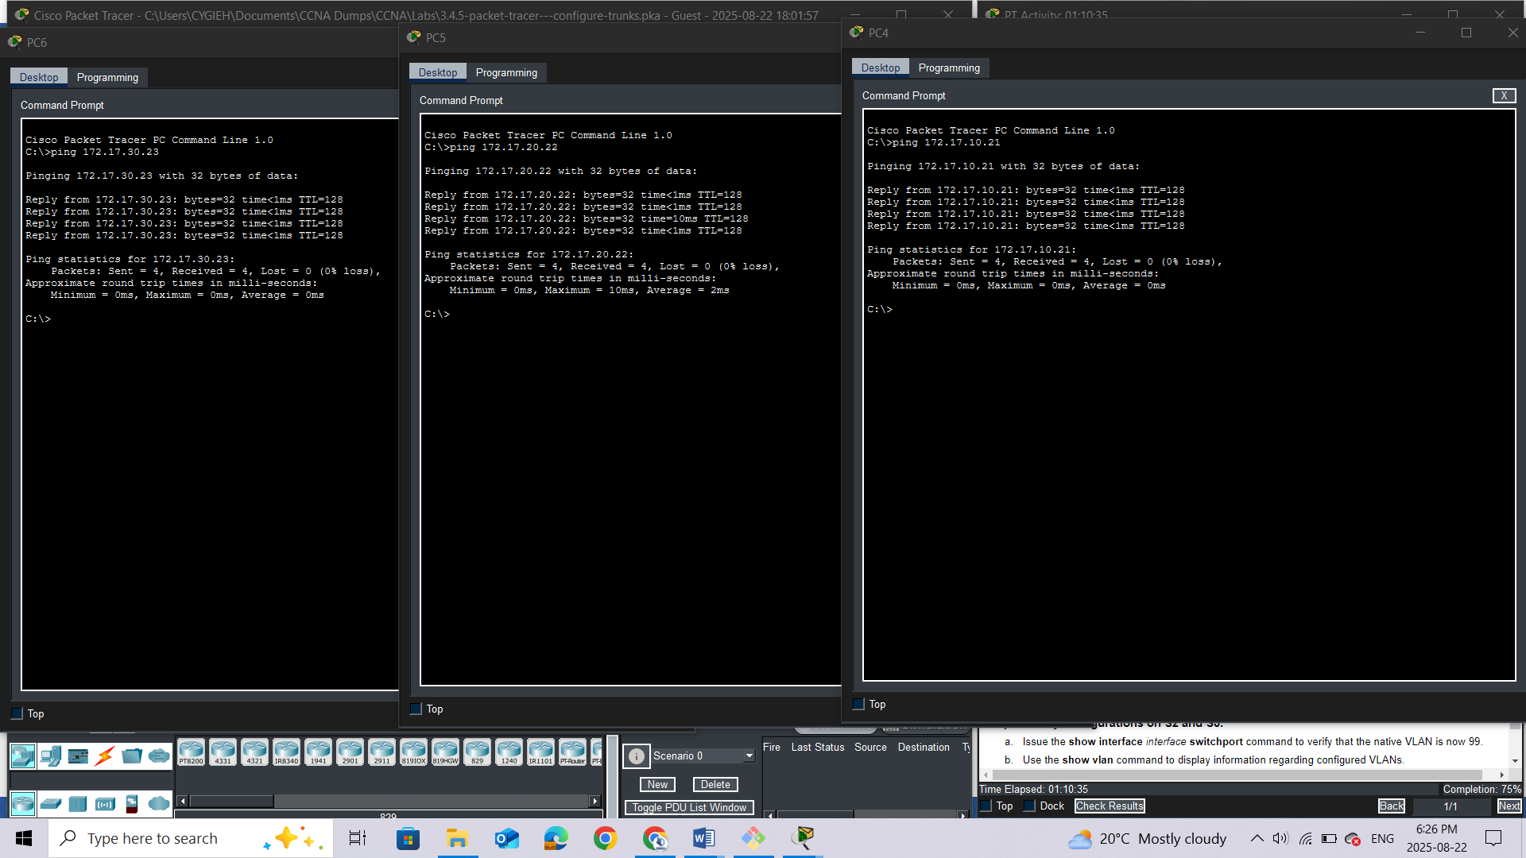

#### Step 2: Verify trunking is enabled on S2 and S3.

On **S2**and **S3**, issue the **show interface trunk** command to confirm that DTP has successfully negotiated trunking with S1 on S2 and S3. The output also displays information about the trunk interfaces on S2 and S3. You will learn more about DTP later in the course.

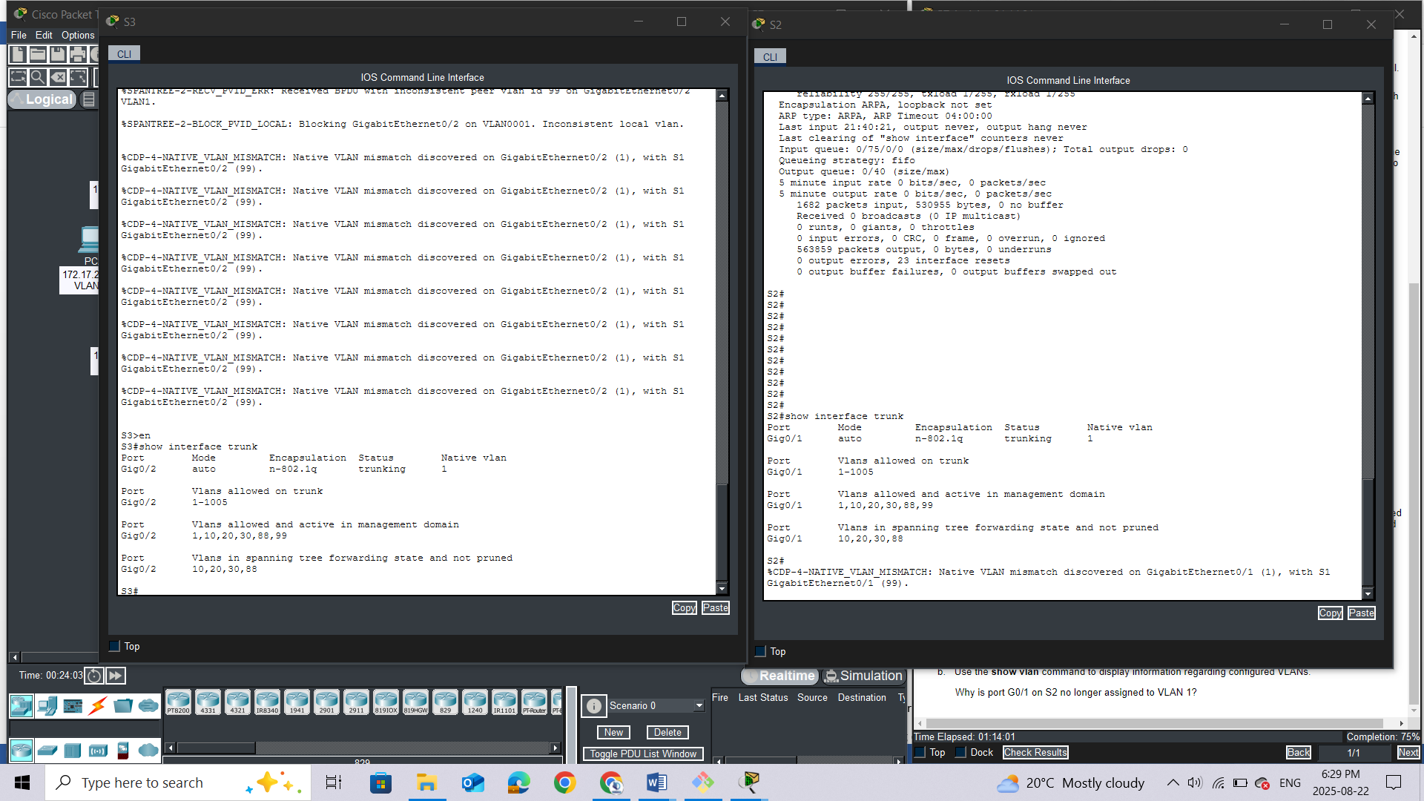

Question:

Which active VLANs are allowed to cross the trunk? ***1-1005***

#### Step 3: Correct the native VLAN mismatch on S2 and S3.

1. Configure VLAN 99 as the native VLAN for the appropriate interfaces on S2 and S3.

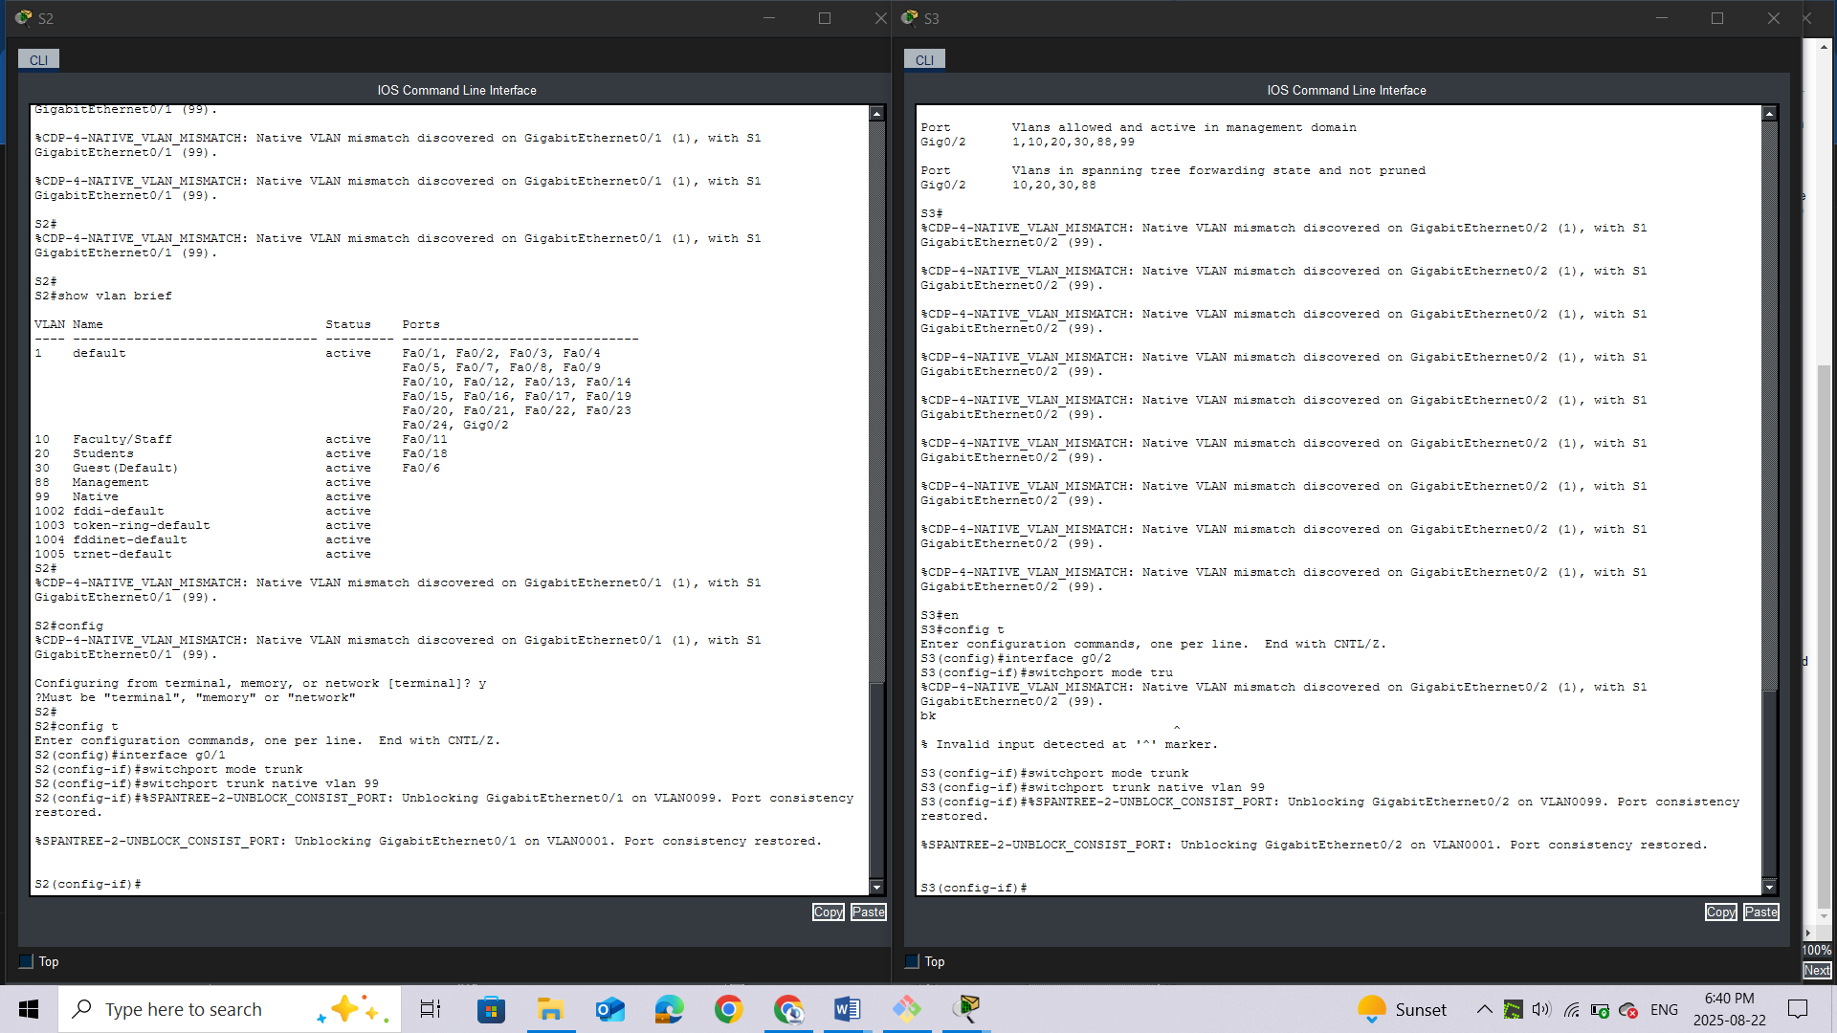

1. Issue **show interface trunk** command to verify the correct native VLAN configuration.

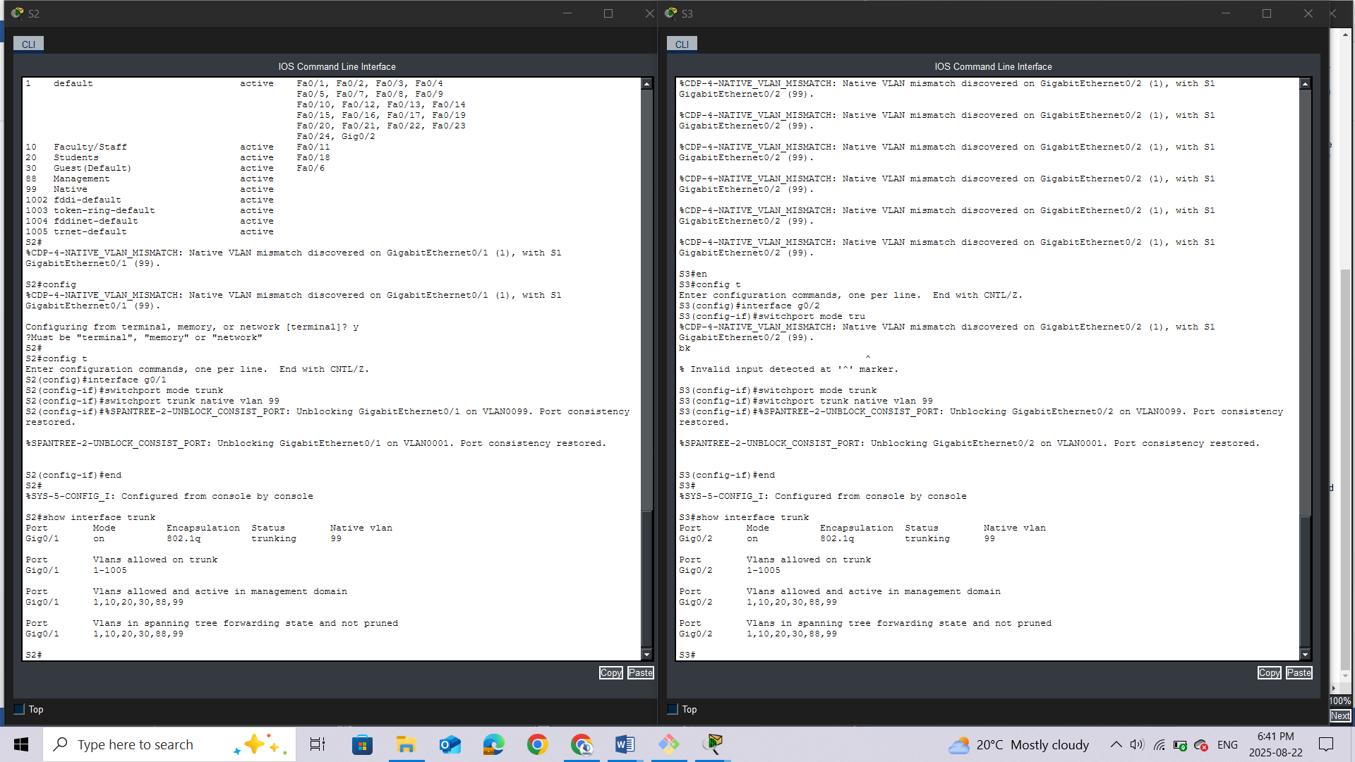

#### Step 4: Verify configurations on S2 and S3.

1. Issue the **show interface***interface***switchport** command to verify that the native VLAN is now 99.

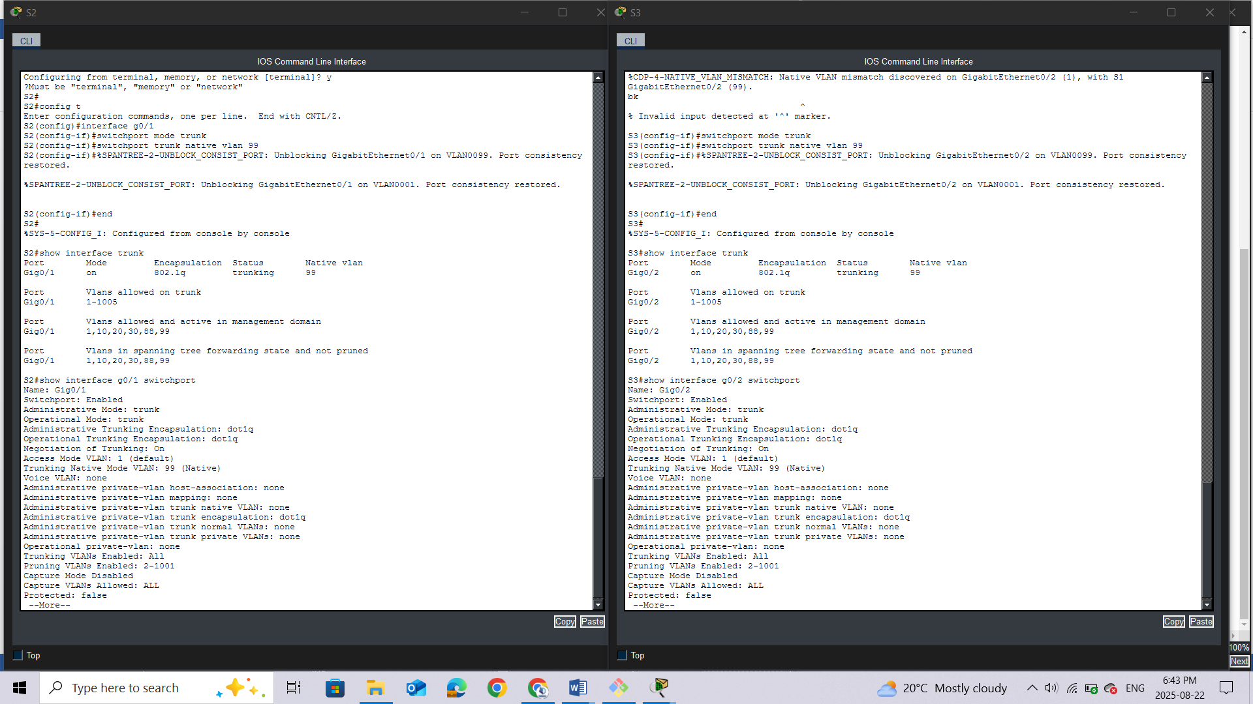

1. Use the **show vlan** command to display information regarding configured VLANs.

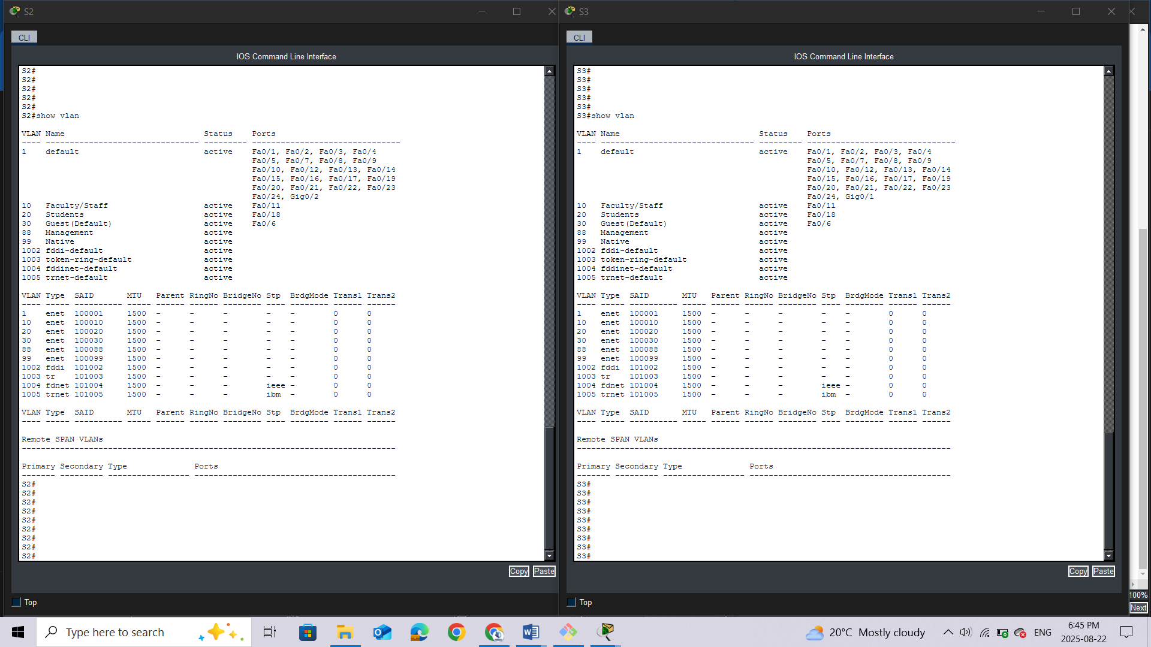

## Question:

Why is port G0/1 on S2 no longer assigned to VLAN 1? ***Because we converted it to trunk***

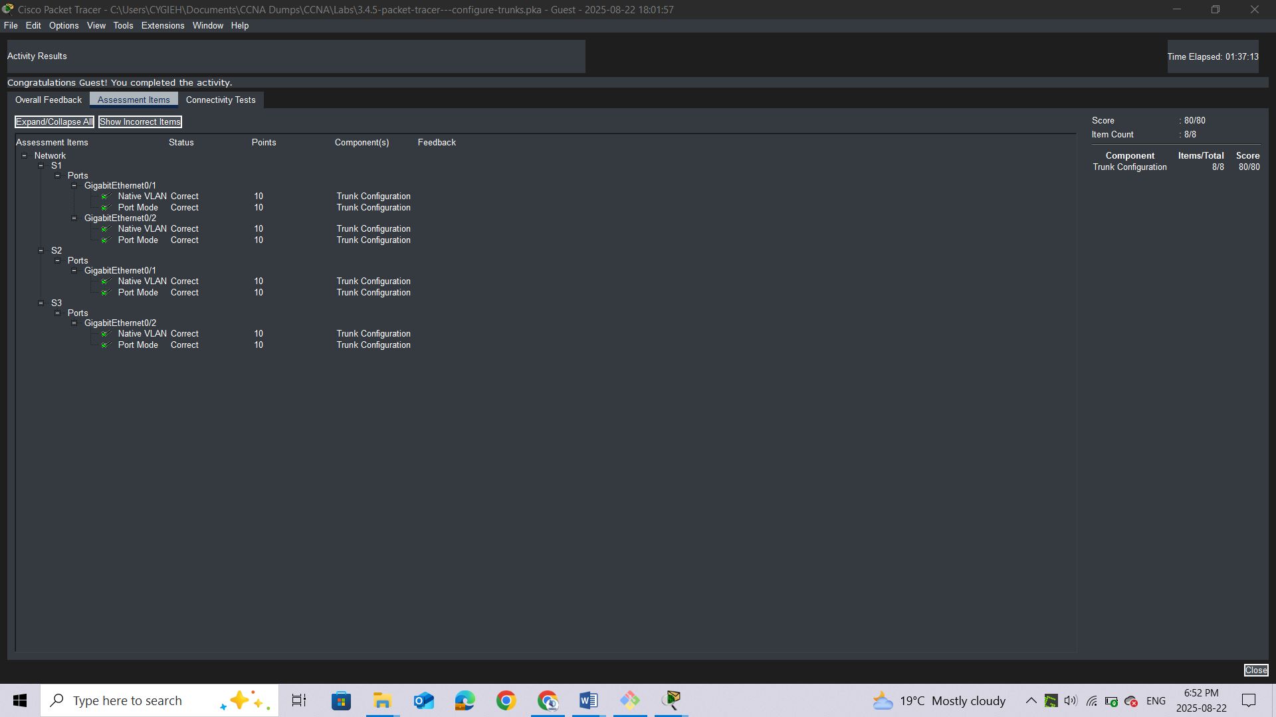

# Lab 5: Configure VLANs and Trunking

## Topology

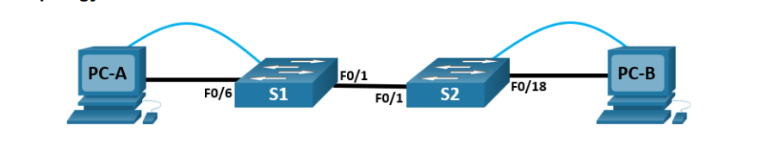

## Addressing Table

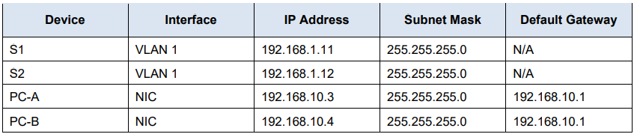

## Objectives

**Part 1: Build the Network and Configure Basic Device Settings**

**Part 2: Create VLANs and Assign Switch Ports**

**Part 3: Maintain VLAN Port Assignments and the VLAN Database**

**Part 4: Configure an 802.1Q Trunk Between the Switches**

## Background / Scenario

Modern switches use virtual local-area networks (VLANs) to improve network performance by separating large Layer 2 broadcast domains into smaller ones. VLANs can also be used as a security measure by controlling which hosts can communicate. In general, VLANs make it easier to design a network to support the goals of an organization.

VLAN trunks are used to span VLANs across multiple devices. Trunks allow the traffic from multiple VLANS to travel over a single link, while keeping the VLAN identification and segmentation intact.

In this Packet Tracer Physical Mode (PTPM) activity, you will create VLANs on both switches in the topology, assign VLANs to switch access ports, and verify that VLANs are working as expected. You will then create a VLAN trunk between the two switches to allow hosts in the same VLAN to communicate through the trunk, regardless of which switch to which the host is attached.

## Instructions

### Part 1: Build the Network and Configure Basic Device Settings

In Part 1, you will set up the network topology and configure basic settings on the PC hosts and switches.

#### Step 1: Build the network as shown in the topology.

Attach the devices as shown in the topology diagram, and cable as necessary.

a.     Click and drag both switch **S1** and **S2** to the **Rack**.

**Note**: This activity will open with 37% completion because the switch ports are all shutdown. When you install the switches in the rack, the ports will automatically be activated. After about a minute, the score will drop to 1%. Later in the activity, you will shut down unused ports.

b.     Click and drag both **PC-A** and **PC-B** to the **Table** and use the power button to turn them on.

c.     Provide network connectivity by connecting **Copper Straight-through** cables, as shown in the topology.

d.     Connect **Console Cable** from device **PC-A** to **S1** and from device **PC-B** to **S2**.

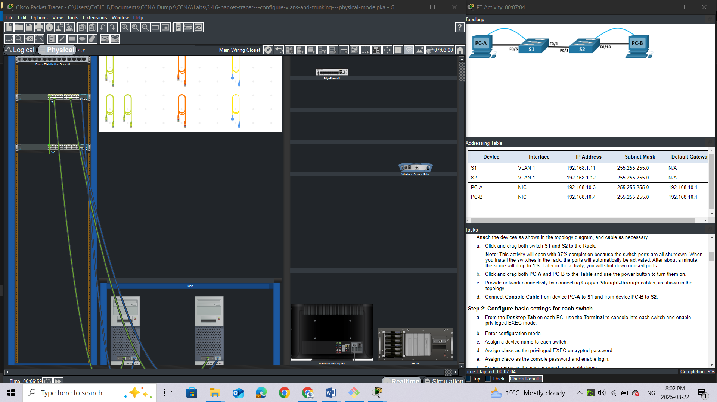

#### Step 2: Configure basic settings for each switch.

a.     From the **Desktop** **Tab** on each PC, use the **Terminal** to console into each switch and enable privileged EXEC mode.

*Open configuration window*

b.     Enter configuration mode.

c.     Assign a device name to each switch.

d.     Assign **class** as the privileged EXEC encrypted password.

e.     Assign **cisco** as the console password and enable login.

f.      Assign **cisco** as the vty password and enable login.

g.     Encrypt the plaintext passwords.

h.     Create a banner that warns anyone accessing the device that unauthorized access is prohibited.

i.      Configure the IP address listed in the Addressing Table for VLAN 1 on the switch.

**Note**: The VLAN 1 address is not grade because you will remove it later in the activity. However, you will need VLAN 1 to test connectivity later in this Part.

j.      Shut down all interfaces that will not be used.

k.     Set the clock on each switch.

**Note**: The clock setting cannot be graded in Packet Tracer.

l.      Save the running configuration to the startup configuration file.

*Close configuration window*

#### Step 3: Configure PC hosts.

From the **Desktop** tab on each **PC**, click IP Configuration and enter the addressing information as displayed in the Addressing Table.

#### Step 4: Test connectivity.

Test network connectivity by attempting to ping between each of the cabled devices.

#### **Questions:**

Can PC-A ping PC-B?

Can PC-A ping S1?

Can PC-B ping S2?

*Open configuration window*

Can S1 ping S2?

If you answered no to any of the above questions, why were the pings unsuccessful?

*Close configuration window*

### Part 2: Create VLANs and Assign Switch Ports

In Part 2, you will create Management, Operations, Parking_Lot, and Native VLANs on both switches. You will then assign the VLANs to the appropriate interface. The **show vlan** command is used to verify your configuration settings.

#### **Step 1:**Create VLANs on the switches.

From the **Desktop Tab** on each **PC**, use Terminal to continue configuring both network switches.

*Open configuration window*

a.     Create the VLANs on **S1**.

S1(config)# **vlan 10**

S1(config-vlan)# **name Operations**

S1(config-vlan)# **vlan 20**

S1(config-vlan)# **name Parking_Lot**

S1(config-vlan)# **vlan 99**

S1(config-vlan)# **name Management**

S1(config-vlan)# **vlan 1000**

S1(config-vlan)# **name Native**

S1(config-vlan)# **end**

b.     Create the same VLANs on S2.

c.     Issue the **show vlan brief** command to view the list of VLANs on **S1**.

S1# **show vlan brief**

VLAN Name Status Ports

---- -------------------------------- --------- -------------------------------

1 default active Fa0/1, Fa0/2, Fa0/3, Fa0/4

Fa0/5, Fa0/6, Fa0/7, Fa0/8

Fa0/9, Fa0/10, Fa0/11, Fa0/12

Fa0/13, Fa0/14, Fa0/15, Fa0/16

Fa0/17, Fa0/18, Fa0/19, Fa0/20

Fa0/21, Fa0/22, Fa0/23, Fa0/24

Gi0/1, Gi0/2

10 Operations active

20 Parking_Lot active

99 Management active

1000 Native active

1002 fddi-default active

1003 token-ring-default active

1004 fddinet-default active

1005 trnet-default active**Questions:**

What is the default VLAN?

What ports are assigned to the default VLAN?

#### Step 2: Assign VLANs to the correct switch interfaces.

a.     Assign VLANs to the interfaces on **S1**.

1)    Assign PC-A to the Operation VLAN.

S1(config)# **interface f0/6**

S1(config-if)# **switchport mode access**

S1(config-if)# **switchport access vlan 10**

2)    From VLAN 1, remove the management IP address and configure it on VLAN 99.

S1(config)# **interface vlan 1**

S1(config-if)# **no ip address**

S1(config-if)# **interface vlan 99**

S1(config-if)# **ip address 192.168.1.11 255.255.255.0**

S1(config-if)# **end**

b.     Issue the **show vlan** **brief** command and verify that the VLANs are assigned to the correct interfaces.

c.     Issue the **show ip interface brief** command.**Question:**

What is the status of VLAN 99? Explain.

d.     Assign **PC-B** to the Operations VLAN on **S2**.

e.     From VLAN 1, remove the management IP address and configure it on VLAN 99 according to the Addressing Table .

f.      Use the **show vlan brief** command to verify that the VLANs are assigned to the correct interfaces.**Questions:**

Is S1 able to ping S2? Explain.

*Close configuration window*

Is PC-A able to ping PC-B? Explain.

### Part 3: Maintain VLAN Port Assignments and the VLAN Database

In Part 3, you will change port VLAN assignments and remove VLANs from the VLAN database.

#### **Step 1:**Assign a VLAN to multiple interfaces.

From the **Desktop Tab** on each **PC**, use **Terminal** to continue configuring both network switches.

*Open configuration window*

a.     On S1, assign interfaces F0/11 – 24 to VLAN99.

S1(config)# **interface range f0/11-24**

S1(config-if-range)# **switchport mode access**

S1(config-if-range)# **switchport access vlan 99**

S1(config-if-range)# **end**

b.     Issue the **show vlan brief** command to verify VLAN assignments.

c.     Reassign F0/11 and F0/21 to VLAN 10.

d.     Verify that VLAN assignments are correct.

#### Step 2: Remove a VLAN assignment from an interface.

a.     Use the **no** **switchport access vlan** command to remove the VLAN 99 assignment to F0/24.

S1(config)# **interface f0/24**

S1(config-if)# **no switchport access vlan**

S1(config-if)# **end**

b.     Verify that the VLAN change was made.

#### **Question:**

Which VLAN is F0/24 now associated with?

#### Step 3: Remove a VLAN ID from the VLAN database.

a.     Add VLAN 30 to interface F0/24 without issuing the global VLAN command.

S1(config)# **interface f0/24**

S1(config-if)# **switchport access vlan 30**

% Access VLAN does not exist. Creating vlan 30

**Note**: Current switch technology no longer requires that the **vlan** command be issued to add a VLAN to the database. By assigning an unknown VLAN to a port, the VLAN will be created and added to the VLAN database.

b.     Verify that the new VLAN is displayed in the VLAN table.

#### **Question:**

What is the default name of VLAN 30?

c.     Use the **no vlan 30** command to remove VLAN 30 from the VLAN database.

S1(config)# **no vlan 30**

S1(config)# **end**

d.     Issue the **show vlan brief** command. F0/24 was assigned to VLAN 30.

#### **Question:**

After deleting VLAN 30 from the VLAN database, why is F0/24 no longer displayed in the output of the **show vlan brief**command? What VLAN is port F0/24 now assigned to? What happens to the traffic destined to the host that is attached to F0/24?

e.     On interface F0/24, issue the **no switchport access vlan** command.

f.      Issue the **show vlan brief** command to determine the VLAN assignment for F0/24.

#### **Questions:**

To which VLAN is F0/24 assigned?

**Note**: Before removing a VLAN from the database, it is recommended that you reassign all the ports assigned to that VLAN.

Why should you reassign a port to another VLAN before removing the VLAN from the VLAN database?

*Close configuration window*

### Part 4: Configure an 802.1Q Trunk Between the Switches

In Part 4, you will configure interface F0/1 to use the Dynamic Trunking Protocol (DTP) to allow it to negotiate the trunk mode. After this has been accomplished and verified, you will disable DTP on interface F0/1 and manually configure it as a trunk.

#### Step 1: Use DTP to initiate trunking on F0/1.

The default DTP mode of a 2960 switch port is dynamic auto. This allows the interface to convert the link to a trunk if the neighboring interface is set to trunk or dynamic desirable mode.

*Open configuration window*

a.     On **S1**, set F0/1 to negotiate trunk mode.

S1(config)# **interface f0/1**

S1(config-if)# **switchport mode dynamic desirable**

Sep 19 02:51:47.257: %LINEPROTO-5-UPDOWN: Line protocol on Interface FastEthernet0/1, changed state to up

Sep 19 02:51:47.291: %LINEPROTO-5-UPDOWN: Line protocol on Interface Vlan99, changed state to up

You should also receive link status messages on S2.

S2#

Sep 19 02:42:19.424: %LINK-3-UPDOWN: Interface FastEthernet0/1, changed state to up

Sep 19 02:42:21.454: %LINEPROTO-5-UPDOWN: Line protocol on Interface Vlan99, changed state to up

Sep 19 02:42:22.419: %LINEPROTO-5-UPDOWN: Line protocol on Interface FastEthernet0/1, changed state to up

b.     On **S1** and **S2**, issue the **show vlan brief** command. Interface F0/1 is no longer assigned to VLAN 1. Trunked interfaces are not listed in the VLAN table.

c.     Issue the **show interfaces trunk** command to view trunked interfaces. Notice that the mode on **S1** is set to desirable, and the mode on **S2** is set to auto.

S1# **show interfaces trunk**

S2# **show interfaces trunk**

**Note**: By default, all VLANs are allowed on a trunk. The **switchport trunk**command allows you to control what VLANs have access to the trunk. For this activity, keep the default settings. This allows all VLANs to traverse F0/1.

*Close configuration window*

d.     Verify that VLAN traffic is traveling over trunk interface F0/1.

#### **Questions:**

Can S1 ping S2?

Can PC-A ping PC-B?

Can PC-A ping S1?

Can PC-B ping S2?

If you answered no to any of the above questions, explain below.

#### Step 2: Manually configure trunk interface F0/1.

The **switchport mode trunk** command is used to manually configure a port as a trunk. This command should be issued on both ends of the link.

a.     On interface F0/1, change the switchport mode to force trunking. Make sure to do this on both switches.

*Open configuration window*

S1(config)# **interface f0/1**

S1(config-if)# **switchport mode trunk**

b.     Issue the **show interfaces trunk** command to view the trunk mode. Notice that the mode changed from **desirable** to **on**.

S1# **show interfaces trunk**

c.     Modify the trunk configuration on both switches by changing the native VLAN from VLAN 1 to VLAN 1000.

S1(config)# **interface f0/1**

S1(config-if)# **switchport trunk native vlan 1000**

d.     Issue the **show interfaces trunk** command to view the trunk. Notice the Native VLAN information is updated.

S2# **show interfaces trunk**

#### **Questions:**

Why might you want to manually configure an interface to trunk mode instead of using DTP?

Why might you want to change the native VLAN on a trunk?

*Close configuration window*

*Close configuration window*

### Reflection Questions

1.     What is needed to allow hosts on VLAN 10 to communicate to hosts on VLAN 99?

2.     What are some primary benefits that an organization can receive through effective use of VLANs?